

**Sales Automobile Using Salesforce CRM**

College: 7155 - PSG Institute of Technology and Applied Research

Team ID: NM2024TMID00734

Team Lead: SREETHIGAA S - 4EB2829E5AAAC0589E44D2DCF056D0C5

Team Members:

|  |  |
| --- | --- |
| RITANYA T | C6DBD0A4D08667F956C4B7D9E78DC283 |
| SANKARI R K | FEE7C875F7F5474AAB74B3C0F8152199 |
| SREETHIGAA S | 4EB2829E5AAAC0589E44D2DCF056D0C5 |
| SRINITHI A | A752A0A47402E9EA362482A73E55BFC5 |
| THAMIZHARASI K | 2FDD39DF72A082492104B30CE3865980 |

1. **Project Overview**

This project is focused on Sales Automobile Using Salesforce CRM, designed to address the challenges in managing leads, customer interactions, and inventory data within the competitive automobile sales industry. The goal is to deliver a comprehensive CRM solution by leveraging Salesforce's robust CRM platform. Through this project, we aim to enhance operational efficiency, improve customer engagement, and increase revenue potential, supporting the long-term goals of automobile sales teams and management.

1. **Objectives**

**Business Goals:**

* Improve Lead Management: Enhance lead tracking and reduce response times for better conversion.
* Centralize Customer Data: Provide a unified customer view for personalized service.
* Optimize Inventory Tracking: Ensure real-time updates on vehicle availability and pricing.
* Automate Routine Tasks: Automate follow-ups and reminders to free up the sales team for high-value activities.
* Enable Insightful Analytics: Use analytics to identify trends, forecast demand, and support informed decision-making.

**Specific Outcomes:**

* Higher Lead Conversion Rates: Enhanced lead nurturing for better conversions.
* Boosted Customer Satisfaction: Personalized service through comprehensive customer data.
* Efficient Inventory Management: Real-time information improves accuracy in sales interactions.
* Increased Productivity: Automation reduces manual workload.

1. **Salesforce Key Features and Concepts Utilized**

* **Comprehensive Lead and Contact Management**

Capture and manage leads, track customer interactions, and organize customer data, ensuring effective engagement throughout the sales cycle.

* **Inventory Management**

Monitor vehicle stock in real-time with details such as model specifications, pricing, and availability, allowing efficient inventory oversight.

* **Automated Workflows**

Automate routine tasks like follow-ups, opportunity tracking, and record updates, simplifying day-to-day operations and reducing manual workload.

* **Personalized Campaigns**

Utilize customer data to create targeted marketing campaigns, increasing relevance and boosting customer engagement.

* **Advanced Reporting and Analytics**

Generate in-depth reports on sales performance, inventory trends, and customer demographics, enabling strategic and data-driven decision-making.

* **Seamless Integration with Marketing Tools**

Connect with various marketing platforms to automate communication, nurture leads, and efficiently convert prospects.

* **User-Friendly Interface**

Leverage Salesforce’s Lightning App for a responsive, easy-to-navigate interface designed to enhance usability for both sales representatives and managers.

1. **Detailed Steps to Solution Design**

1. Creating Developer Account

* We began by creating a Salesforce Developer Account to access a development environment where we could build and customize the application. This setup provided the necessary tools to design, test, and deploy the application.

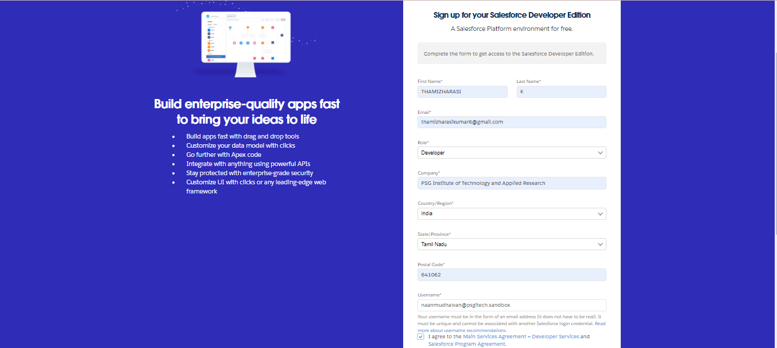

2. Account Activation

* **Activate Account**: Go to your email inbox and verify your account through the link sent by Salesforce (wait up to 10 minutes for the email).
* **Set Password and Security**: After verification, set a new password and answer a security question.
* **Redirect**: You will be redirected to your Salesforce setup page.

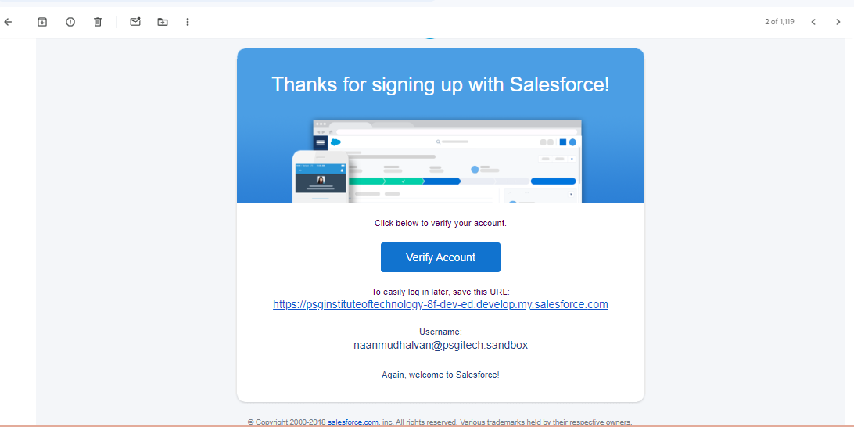

3. Create Automobile Information Object

* **Download and Save File**: Download the spreadsheet and save it as **"Automobile Information.csv"**.
* **Login to Salesforce**: Open Salesforce, go to **Setup**, and select **Object Manager**.
* **Create Custom Object from Spreadsheet**:
  + Click **Create**, then choose **Custom Object from Spreadsheet**.
  + **Login with Salesforce** if prompted, and upload **Automobile Information.csv**.
  + Ensure proper **Record Name** selection and confirm **data types** for fields.
* **Finish Setup**: Click **Next**, enter any final settings, then click **Finish** to complete the object setup and data import

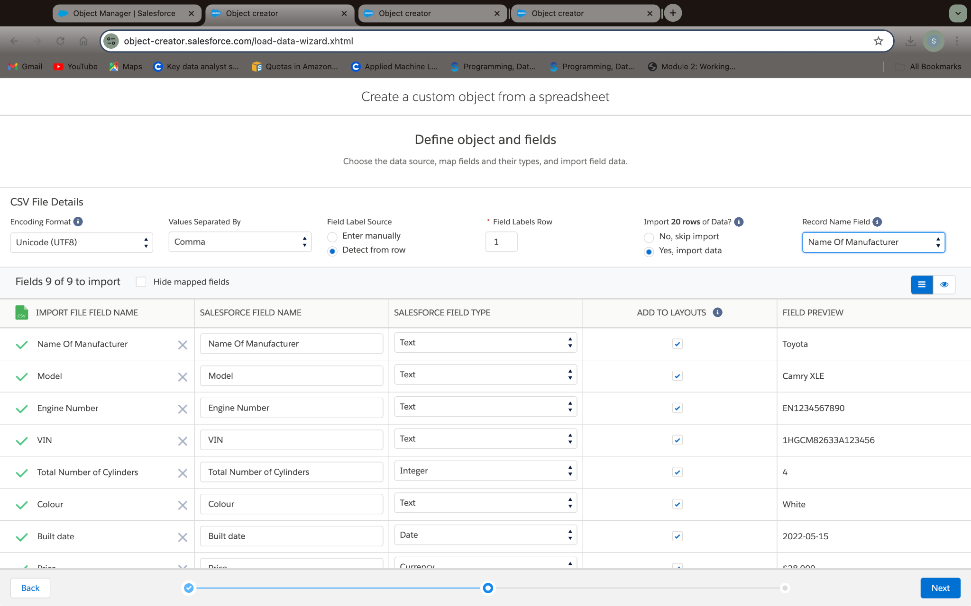

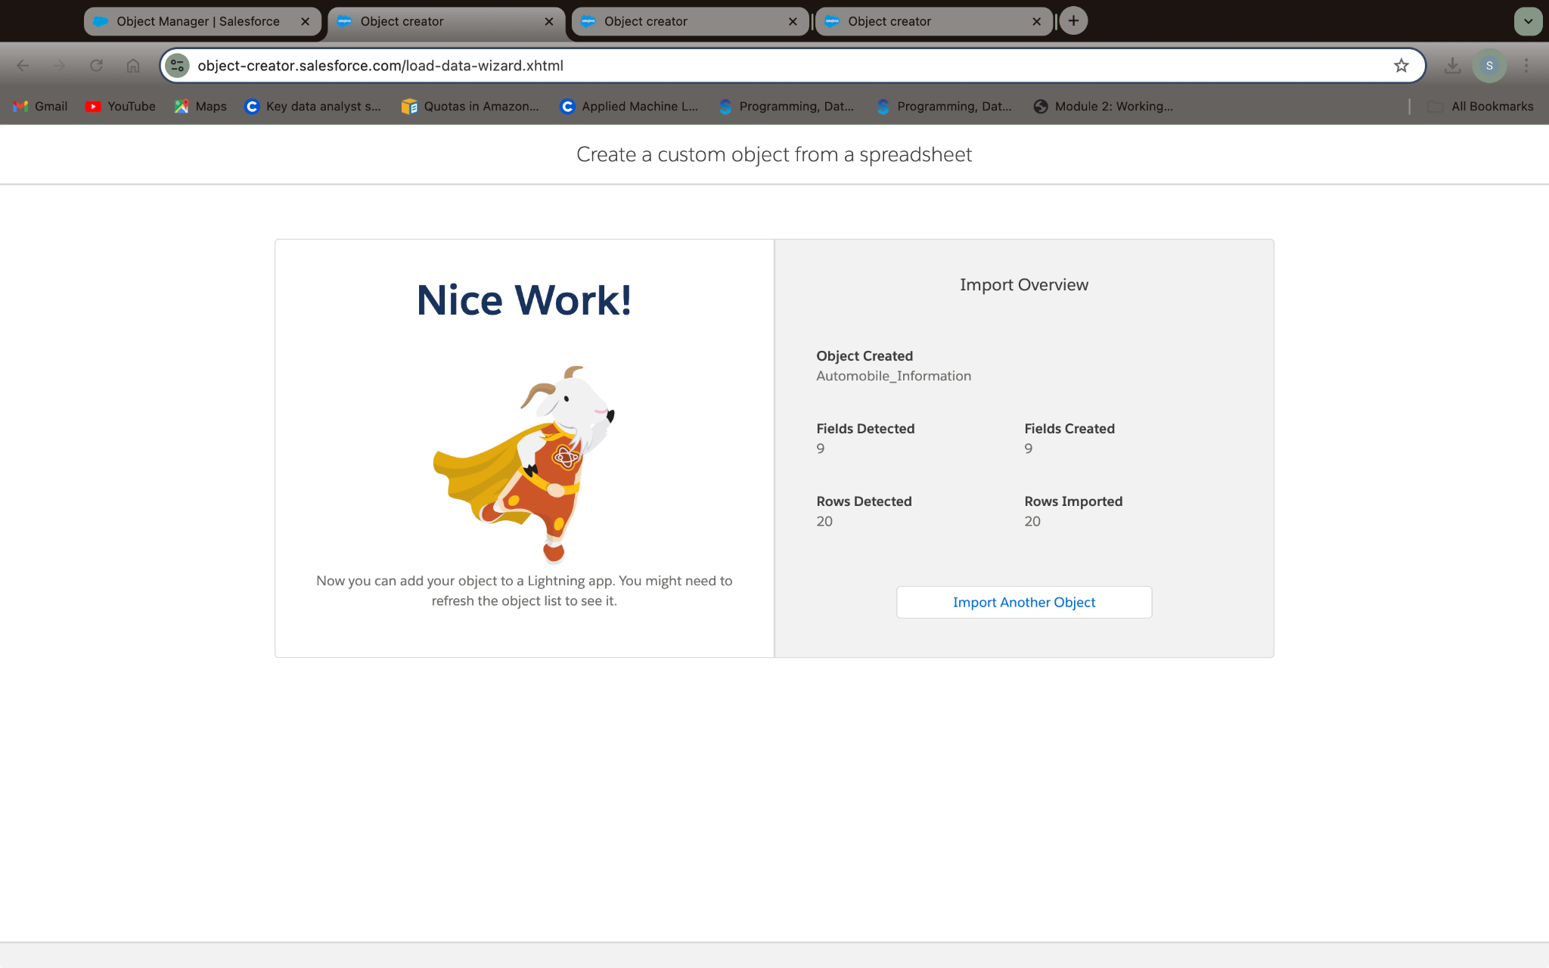

1. Create Invoice Object

* **Repeat Steps**: Follow the same steps as the Automobile Information Object, ensuring the file is saved in CSV format and mapped correctly.

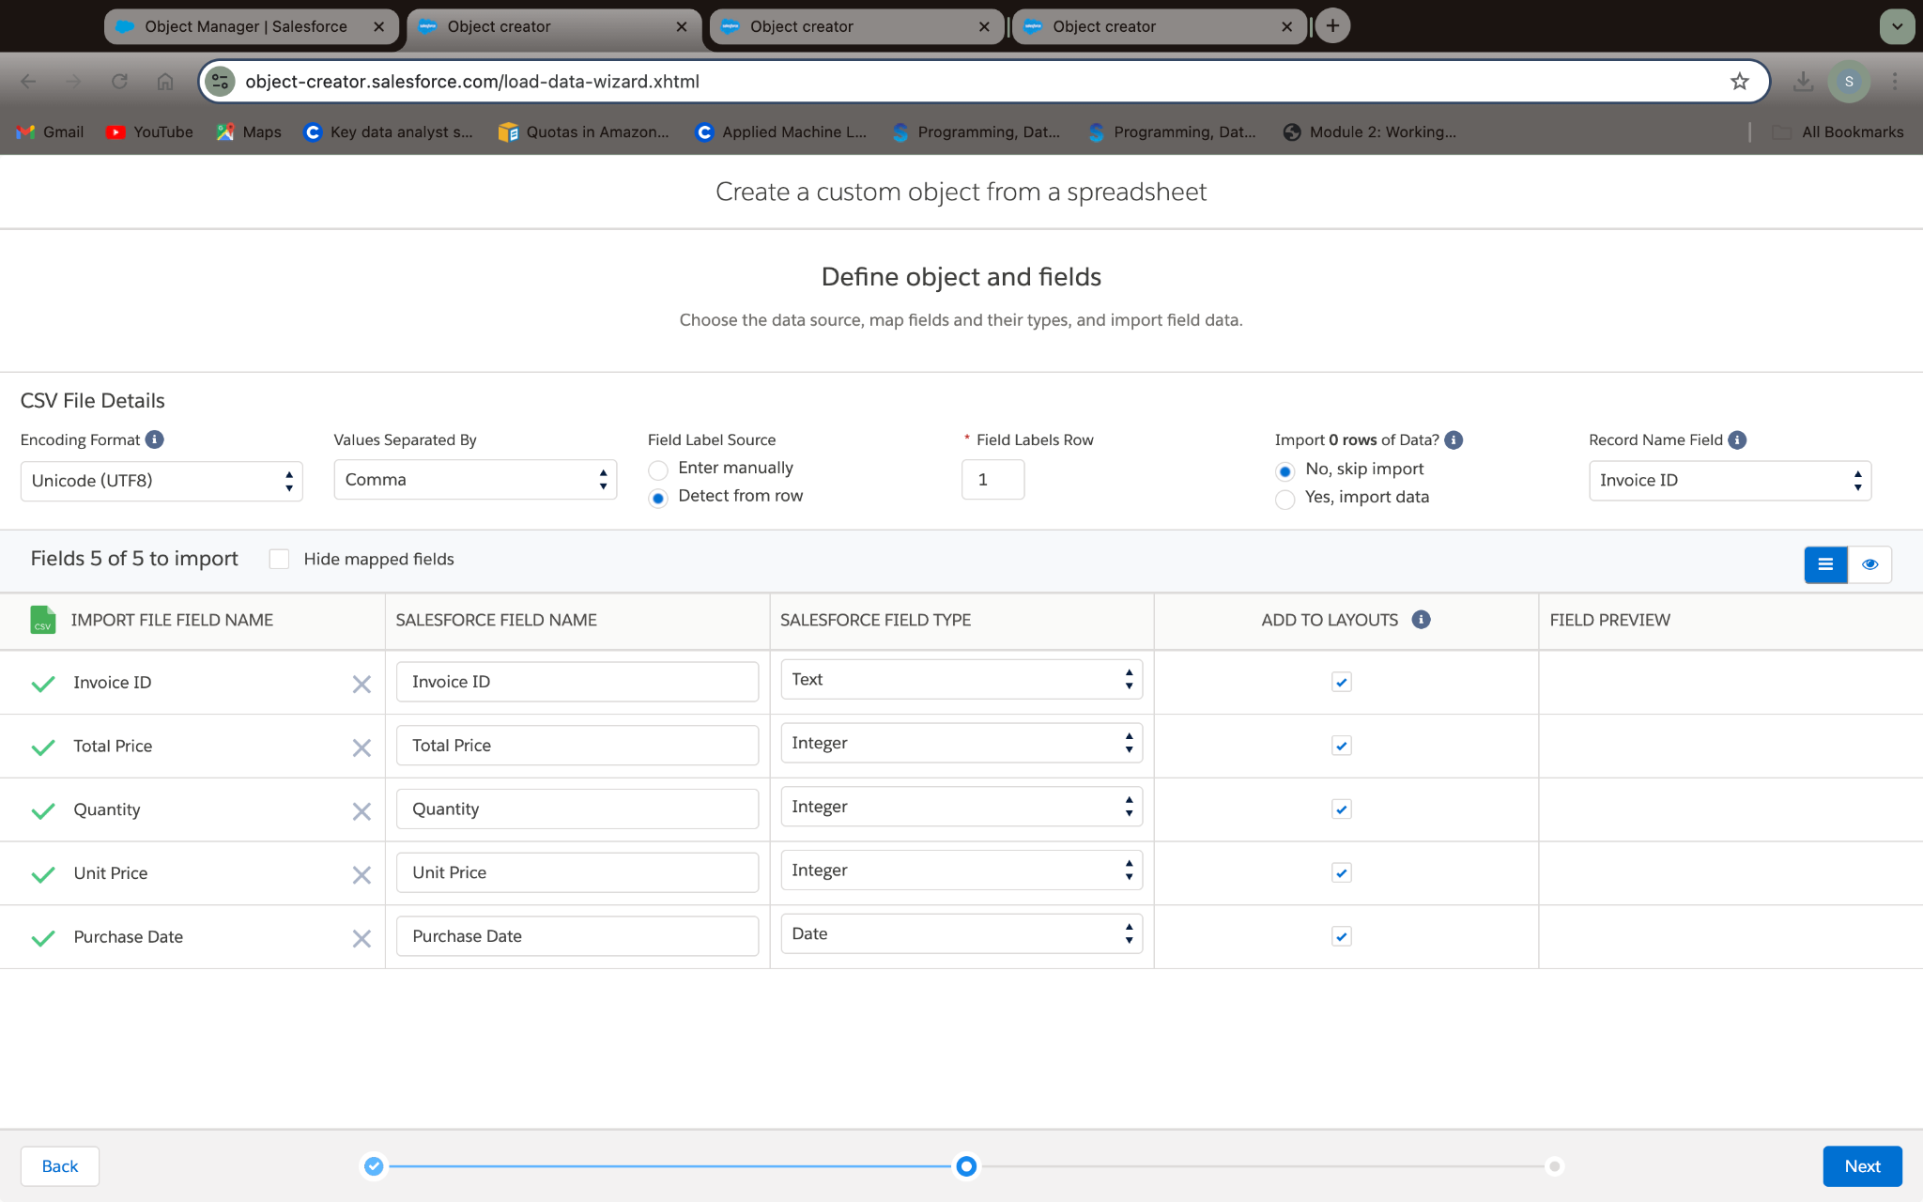

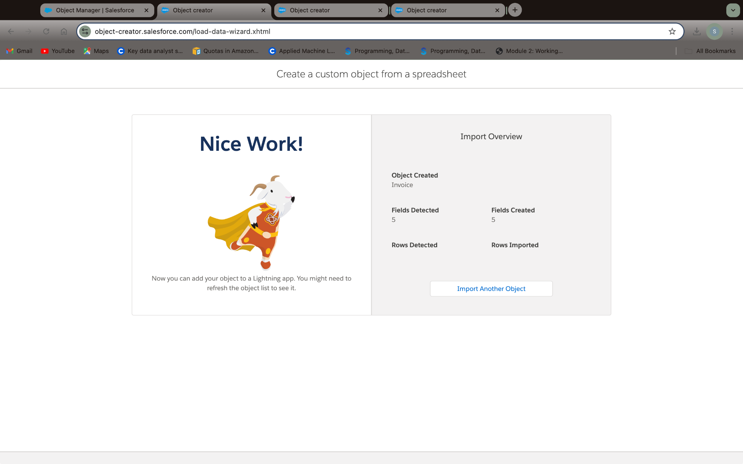

1. Create Automobile Object

* **Open Object Manager**:
  + From **Setup**, go to **Object Manager** > **Create** > **Custom Object**.
* **Enter Object Details**:
  + **Label Name**: Opportunity Automobile
  + **Plural Label Name**: Opportunity Automobiles
  + **Record Name Label**: Opportunity Automobile Id
  + **Data Type**: Auto Number
  + **Display Format**: OA-{0000}
  + **Starting Number**: 1
* **Enable Options**: Select **Allow Reports** and **Allow Search**.
* **Save**: Save the object to complete setup.

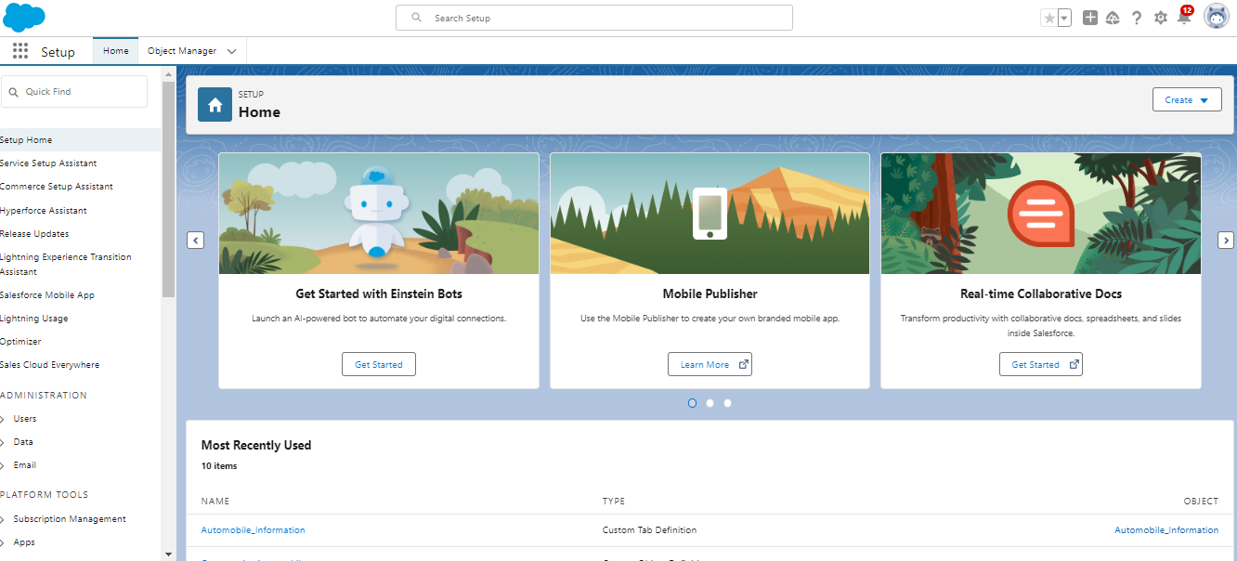

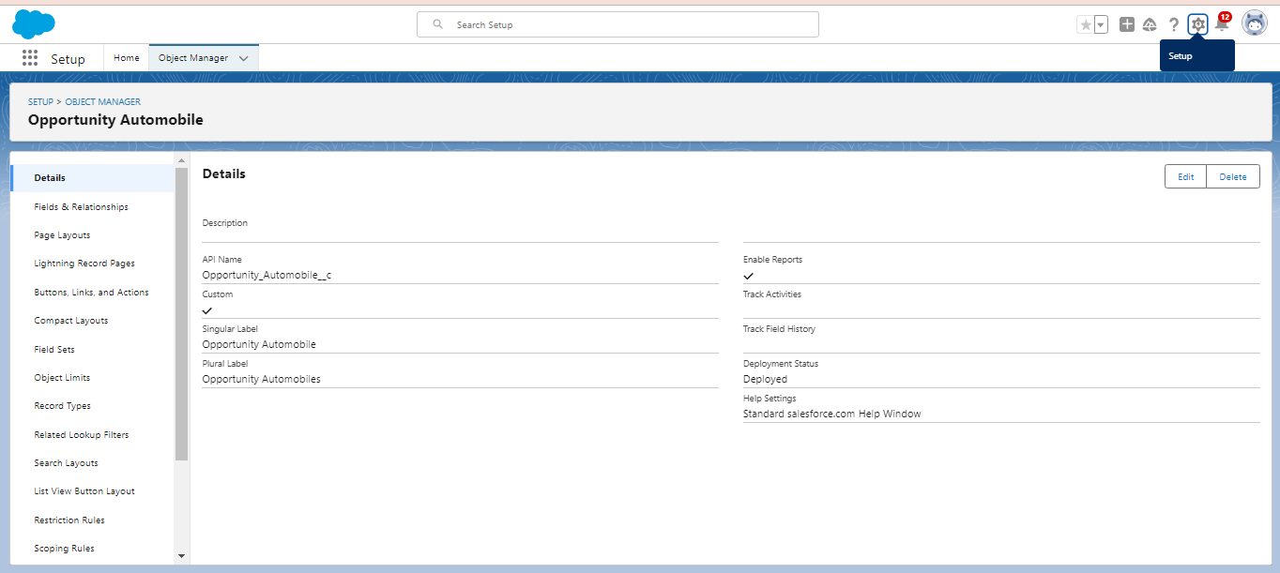

1. Creating a Custom Tab

* **Navigate to Setup**:
  + Go to the **Setup** page, type **Tabs** in the **Quick Find** bar, and select **Tabs**.
* **Create a New Custom Object Tab**:
  + Click **New** (under **Custom Object Tab**).
  + **Select Object**: Choose **Opportunity Automobile**.
  + **Choose Tab Style**: Select any desired tab style.
  + Click **Next** (Add to profiles page) and keep it as **default**.
  + Click **Next** (Add to Custom App) and keep it as **default**.
  + Click **Save**.

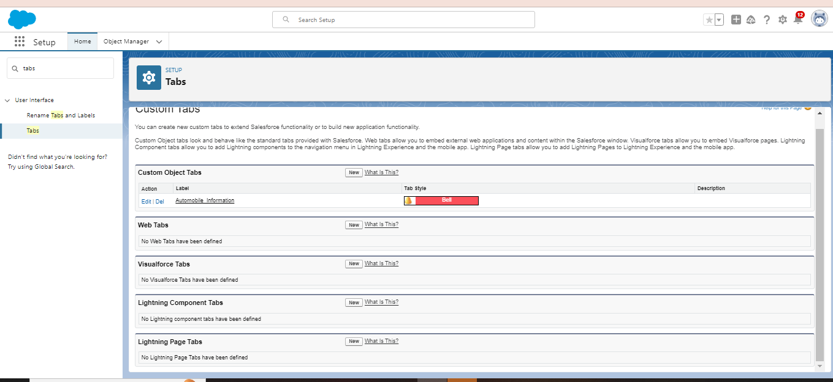

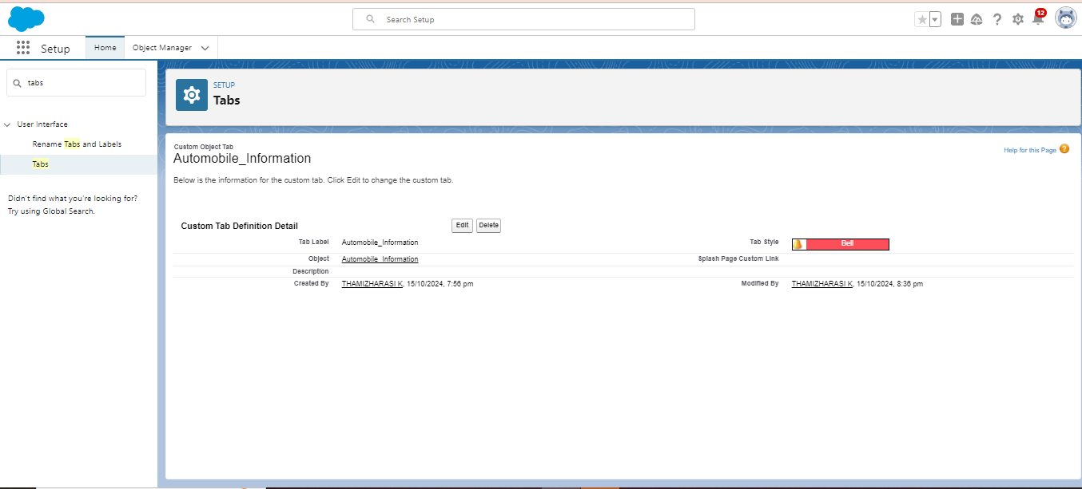

1. Create a Lightning App

* **Navigate to App Manager**:
  + Go to the **Setup** page, search **App Manager** in the **Quick Find** bar, and select **App Manager**.
  + Click on **New Lightning App**.
* **Fill in App Details and Branding**:
  + **App Name**: *Sales Automobile Using Salesforce CRM*
  + **Developer Name**: (auto-populated)
  + **Description**: Provide a meaningful description.
  + **Image**: Optional – add an image if desired.
  + **Primary Color Hex Value**: Keep this as default.
  + Click **Next**.
* **App Options**:
  + On the **App Options** page, keep all settings as **default**.
  + Click **Next**.
* **Utility Items**:
  + On the **Utility Items** page, keep all settings as **default**.
  + Click **Next**.
* **Add Navigation Items**:
  + Use the search bar to find and select the following items:
    - **Account**
    - **Contact**
    - **Opportunities**
    - **Automobile Information**
    - **Opportunity Automobile**
    - **Invoice**
    - **Reports**
    - **Dashboard**
  + Move each item to the navigation list using the arrow button.
  + **Note**: Select **Asset**, the custom object created in the previous activity, as well.
  + Click **Next**.
* **Assign Profiles**:
  + Search for **System Administrator** in the profiles search bar.
  + Move it to the selected profiles using the arrow button.
  + Click **Save & Finish**.

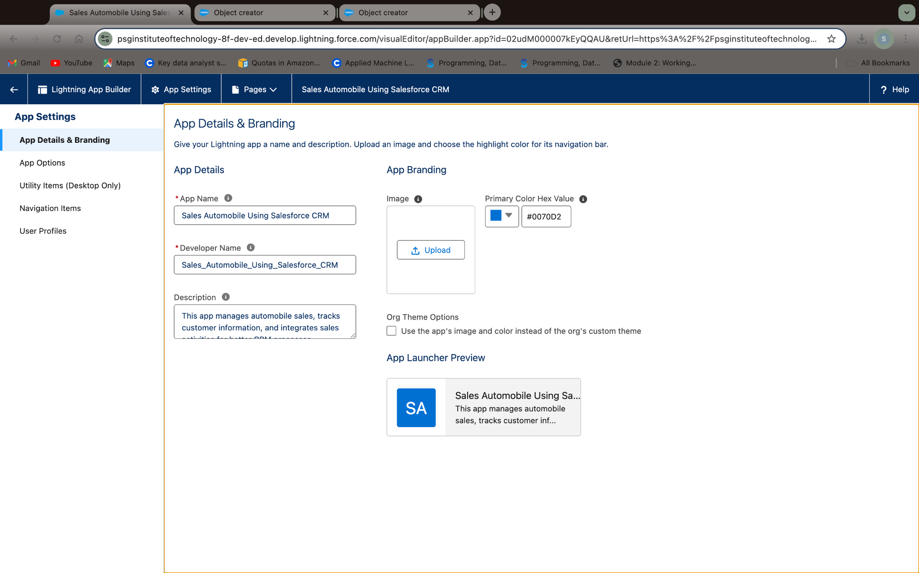

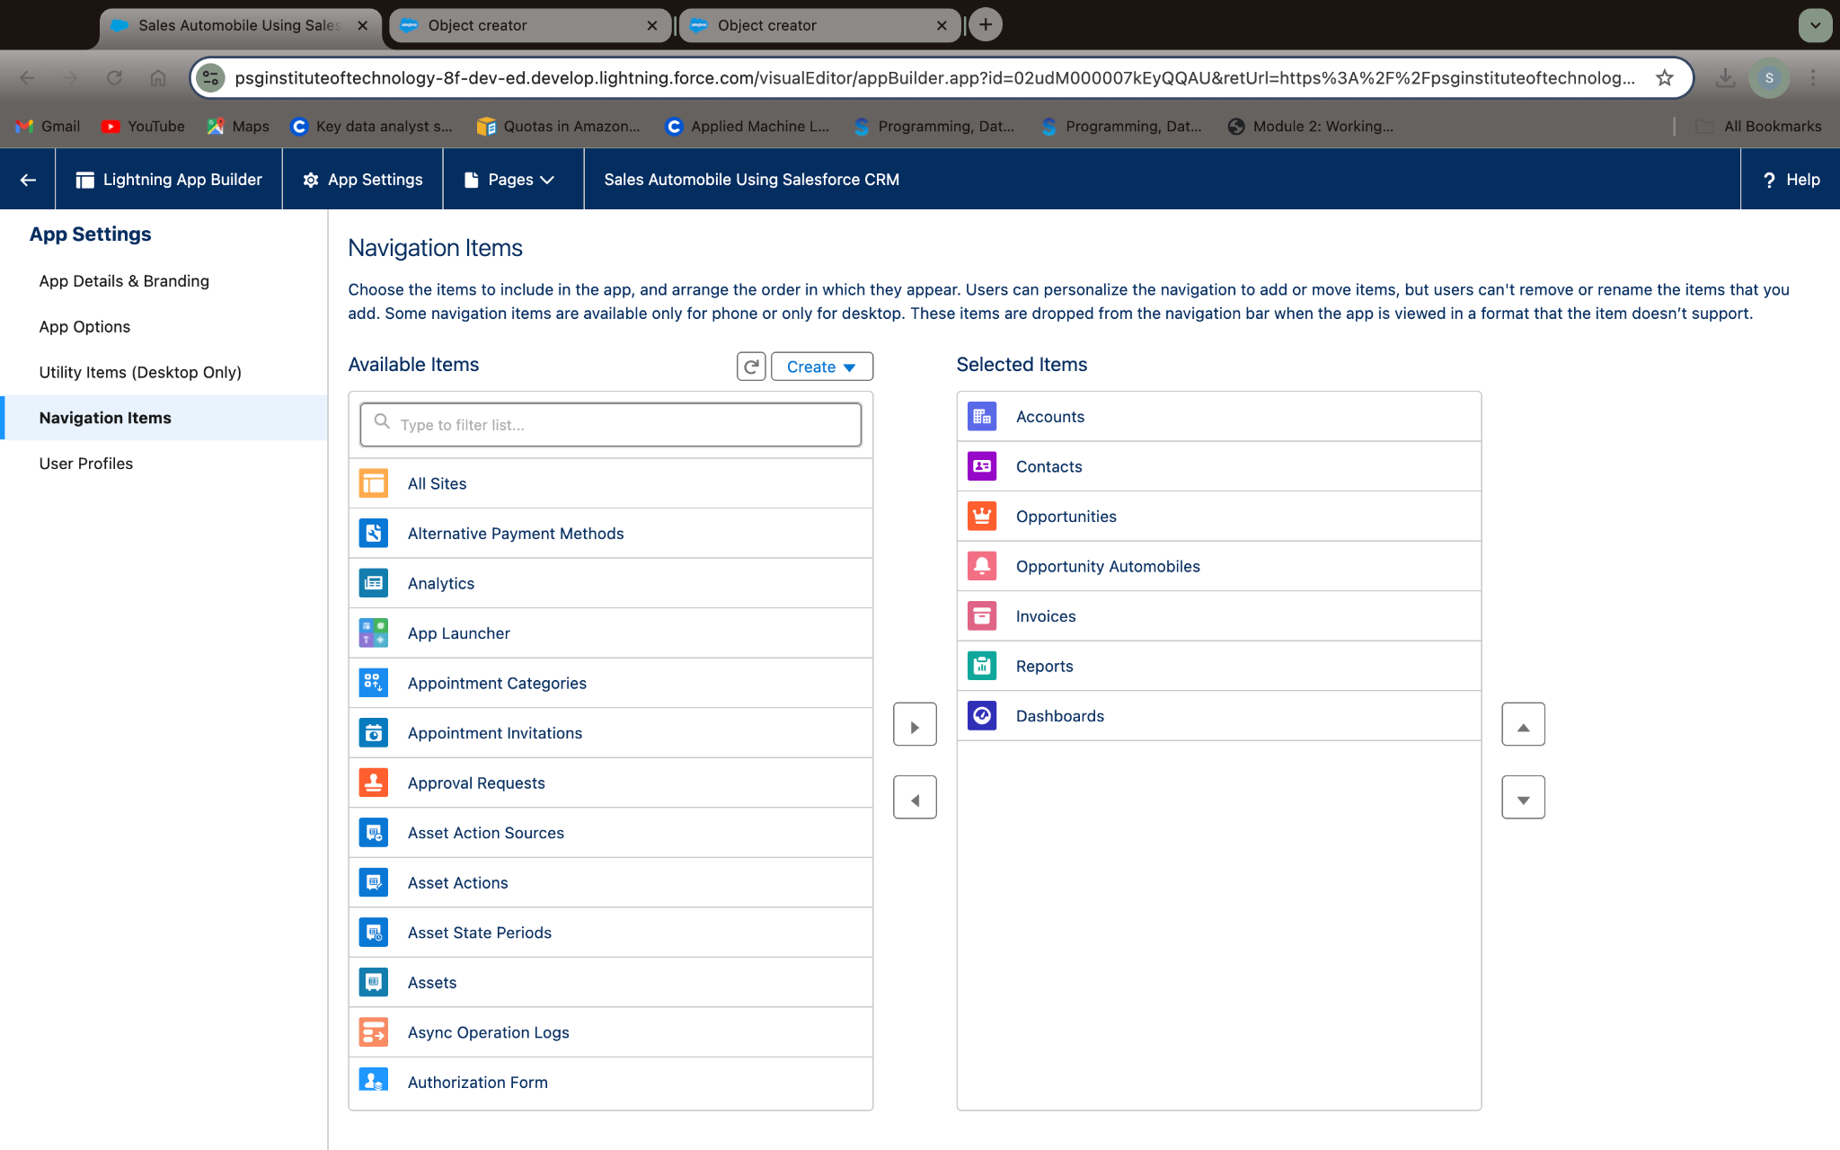

1. Creating Opportunity Master Detail Relationship Field in Opportunity AutoMobile Object

* Go to **Setup** → **Object Manager** → Type **Opportunity Automobile** in the **Quick Find** bar → Click on the object.
* Click on **Fields & Relationships** → Click **New**.
* Select **Data Type** as **Master-Detail Relationship** → Click **Next**.
* Fill in the following details:
  + **Field Label**: Auto-generated as **Opportunity**
  + **Field Name**: Auto-generated as **Opportunity**
* Click **Next** → **Next** → **Save and New**

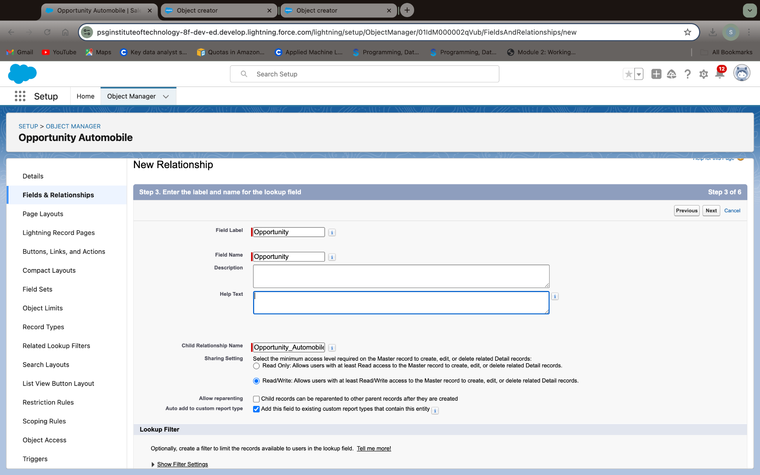

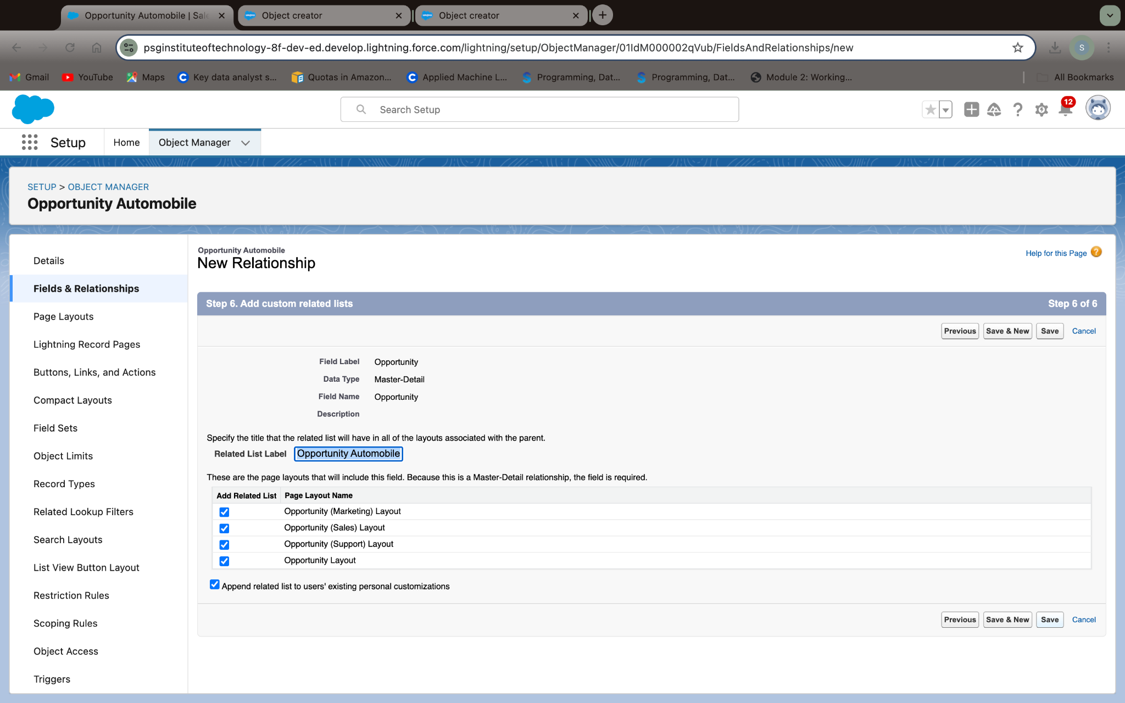

1. Creating the AutoMobile Information Lookup Field in Opportunity Automobile Object

* Go to **Setup** → **Object Manager** → Type **Opportunity Automobile** in the **Quick Find** bar → Click on the object.
* Click on **Fields & Relationships** → Click **New**.
* Select **Data Type** as **Lookup Relationship** → Click **Next**.
* Fill in the following details:
  + **Field Label**: **Automobile**
  + **Field Name**: **Automobile**
* Click **Next** → **Next** → **Save and New**.

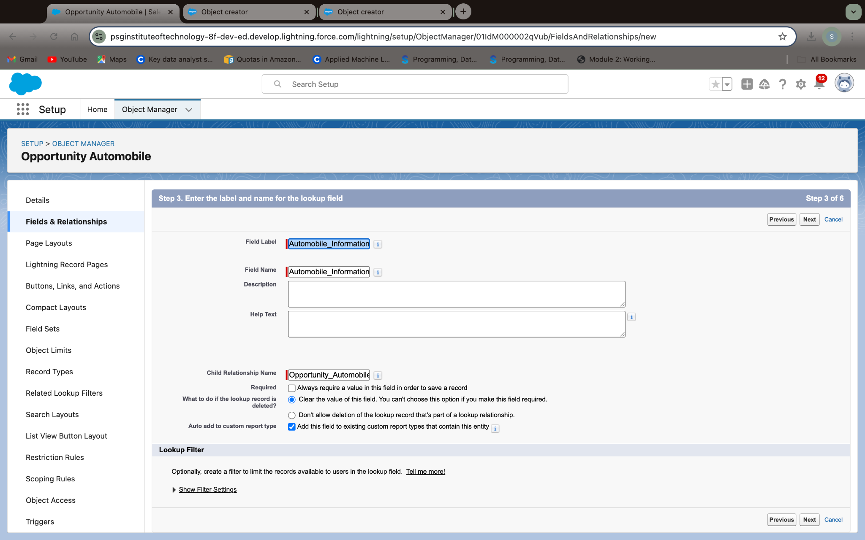

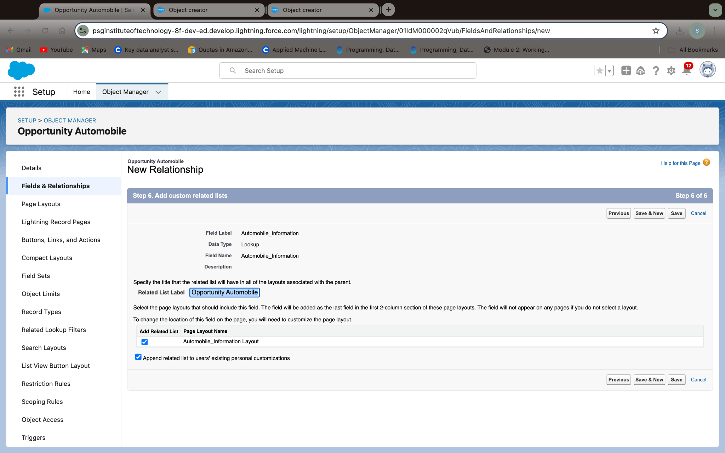

1. Creating Quantity Number Field in Opportunity Automobile Object

* Go to **Setup** → **Object Manager** → Type **Opportunity Automobile** in the **Quick Find** bar → Click on the object.
* Click on **Fields & Relationships** → Click **New**.
* Select **Data Type** as **Number** → Click **Next**.
* Fill in the following details:
  + **Field Label**: **Quantity**
  + **Field Name**: **Quantity**
  + Check the **Required** checkbox.
* Click **Next** → **Next** → **Save and New**.

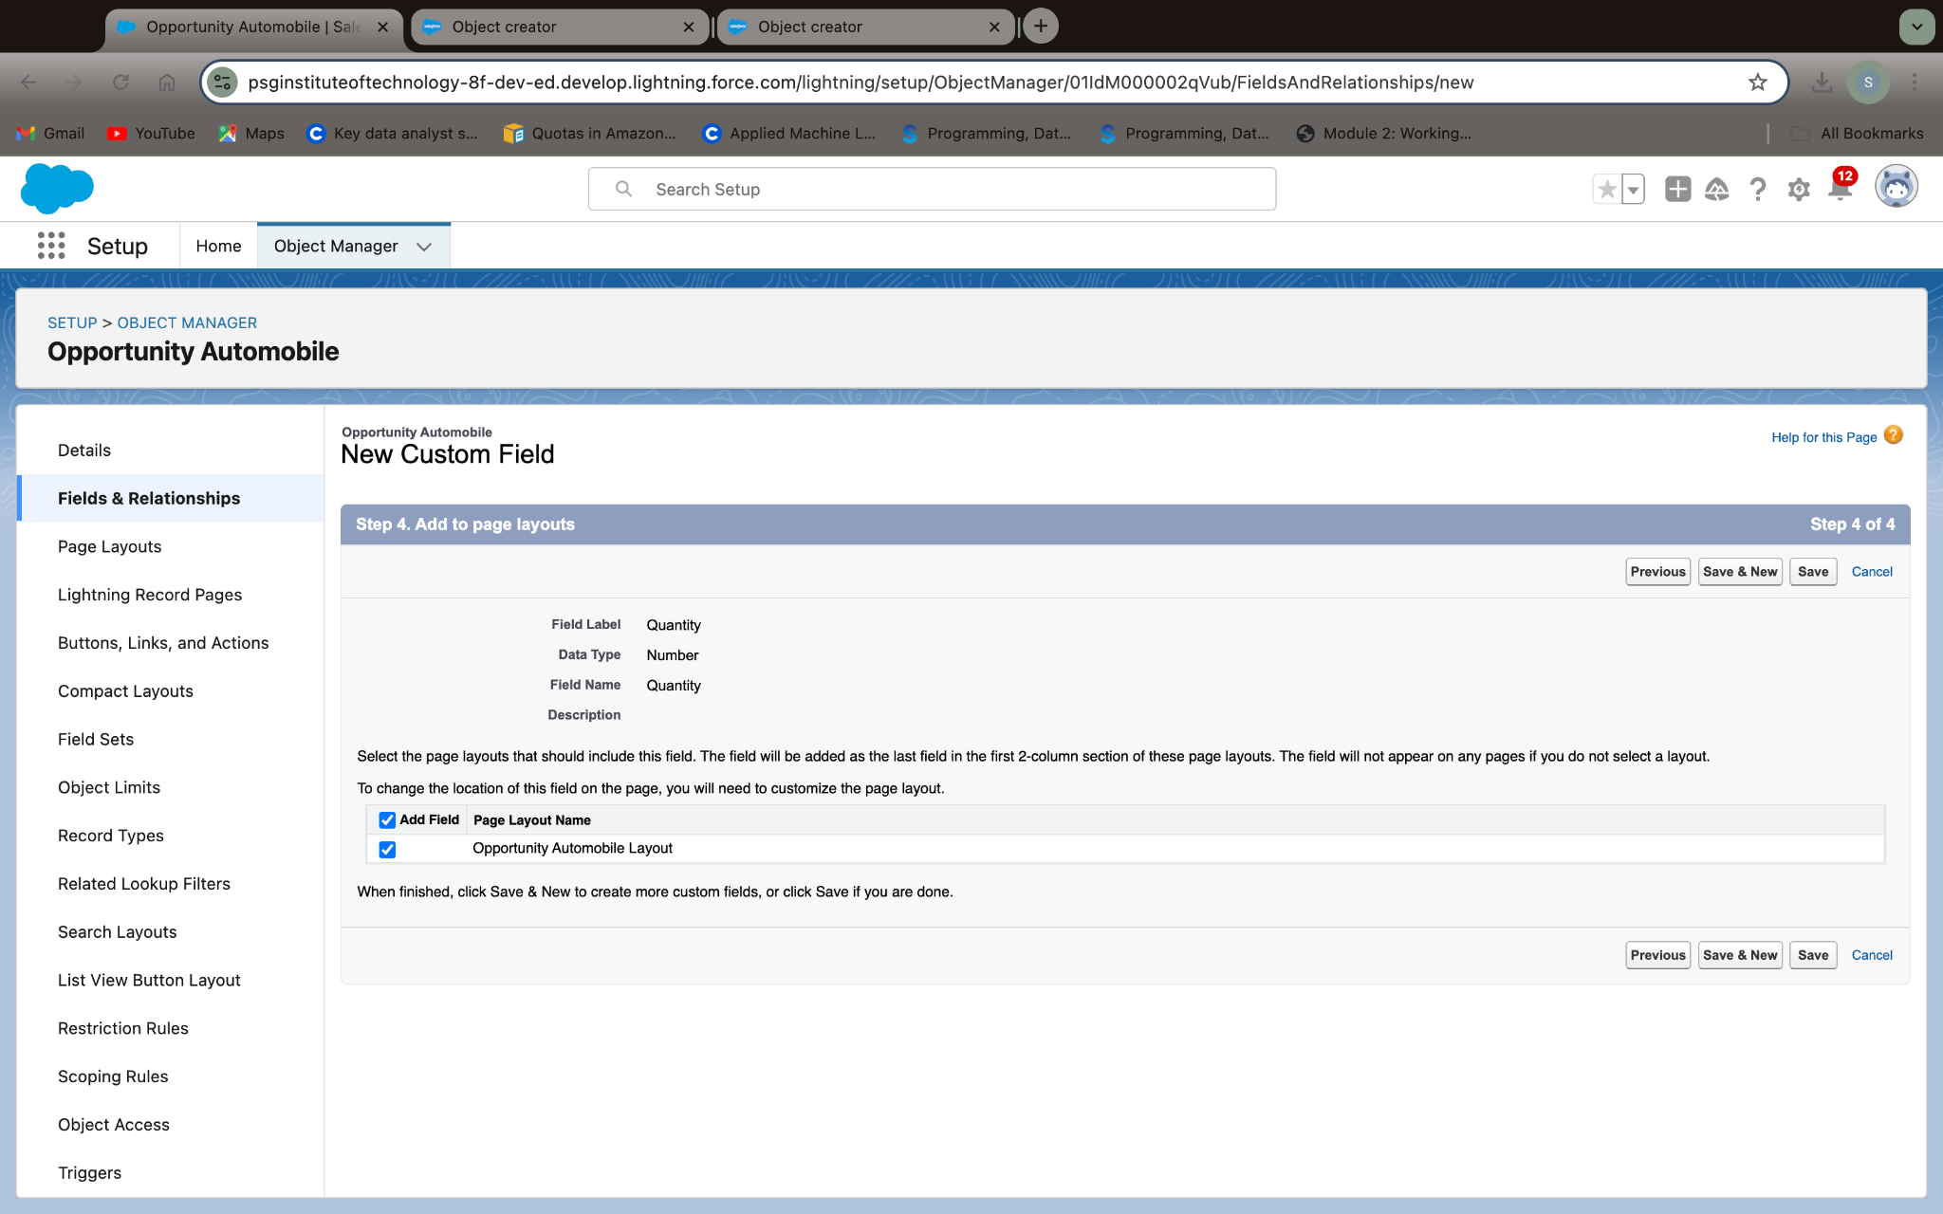

1. Creating Formula Field in Opportunity Automobile Object

* Go to **Setup** → **Object Manager** → Type **Opportunity Automobile** in the **Quick Find** bar → Click on the object.
* Click on **Fields & Relationships** → Click **New**.
* Select **Data Type** as **Formula** → Click **Next**.
* Fill in the following details:
  + **Field Label**: **Unit Price**
  + **Field Name**: **Unit Price**
  + **Formula Return Type**: **Currency** → Set decimal places to **2**.
* Under **Advanced Formula**, write the formula:  
  Automobile__r.Price__c
* Click **Check Syntax** → **Next** → **Next** → **Save & New**.

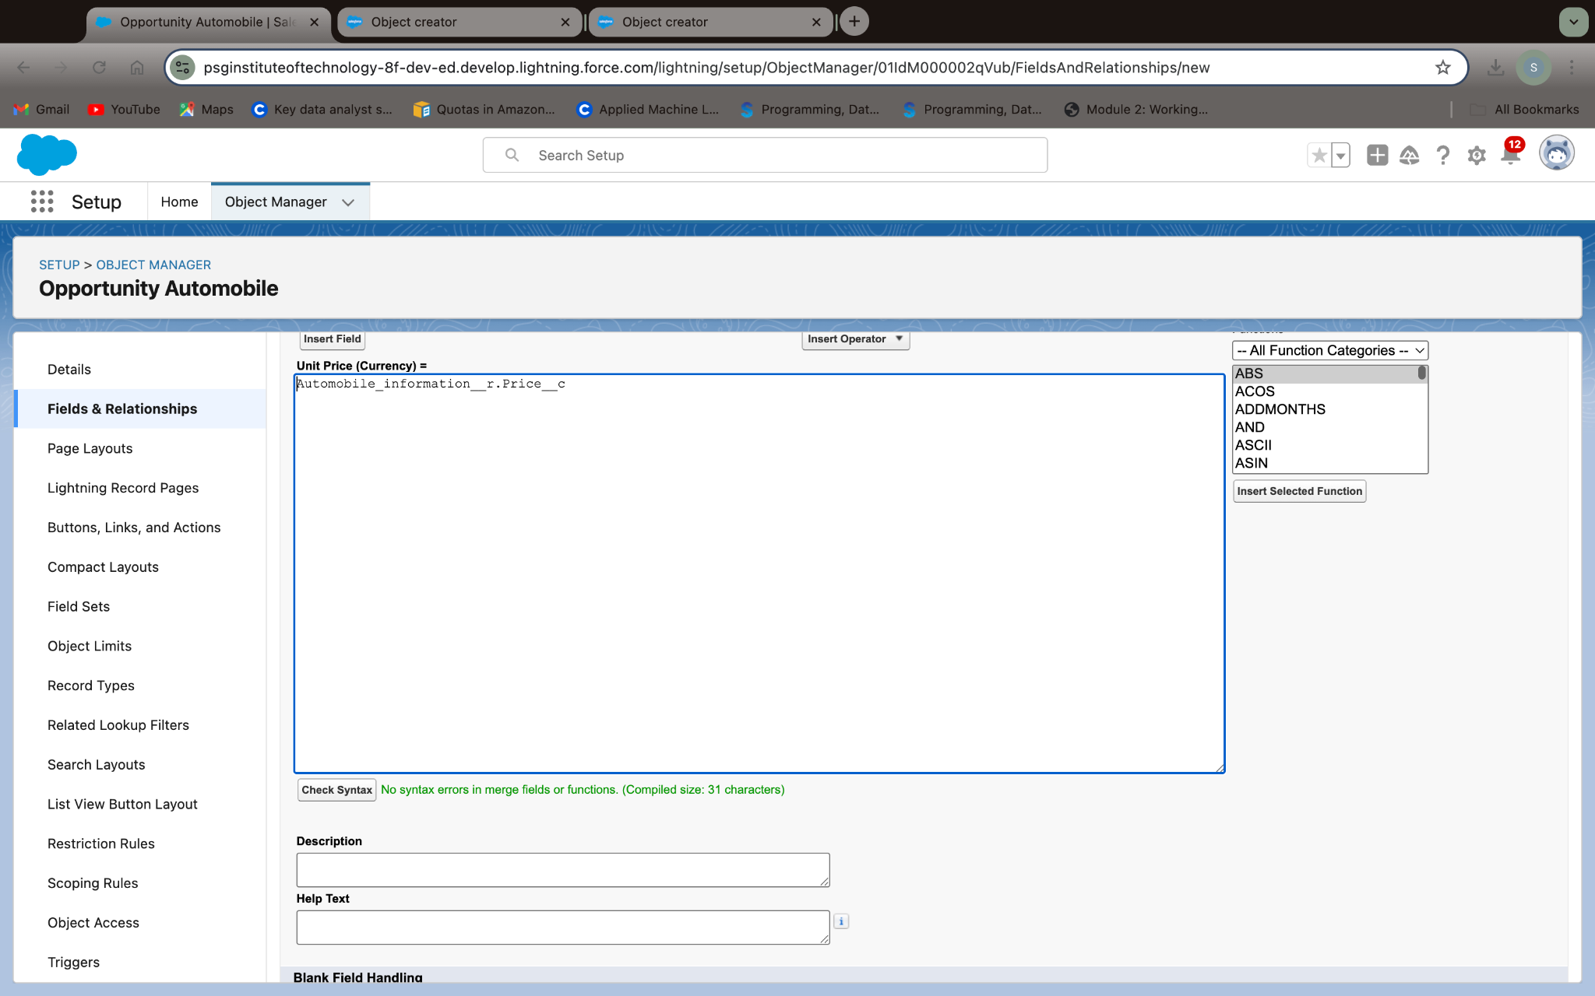

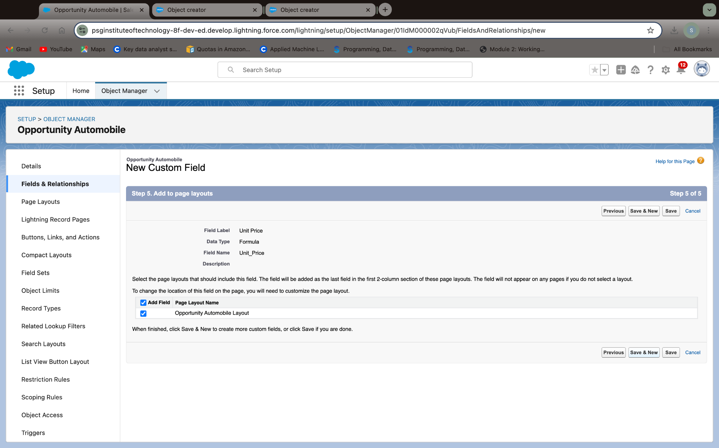

1. Updating field in Invoice Object

* Go to **Setup** → **Object Manager** → Type **Invoice** in the **Quick Find** bar → Click on the object.
* Click on **Fields & Relationships** → Click on the **Edit** button for the **Invoice Id** field.
* Select **Data Type** as **Auto Number** → Click **Next**.
* Set **Display Format**: **I-{0000}**.
* Set the **Starting Number** → Click **Save**.

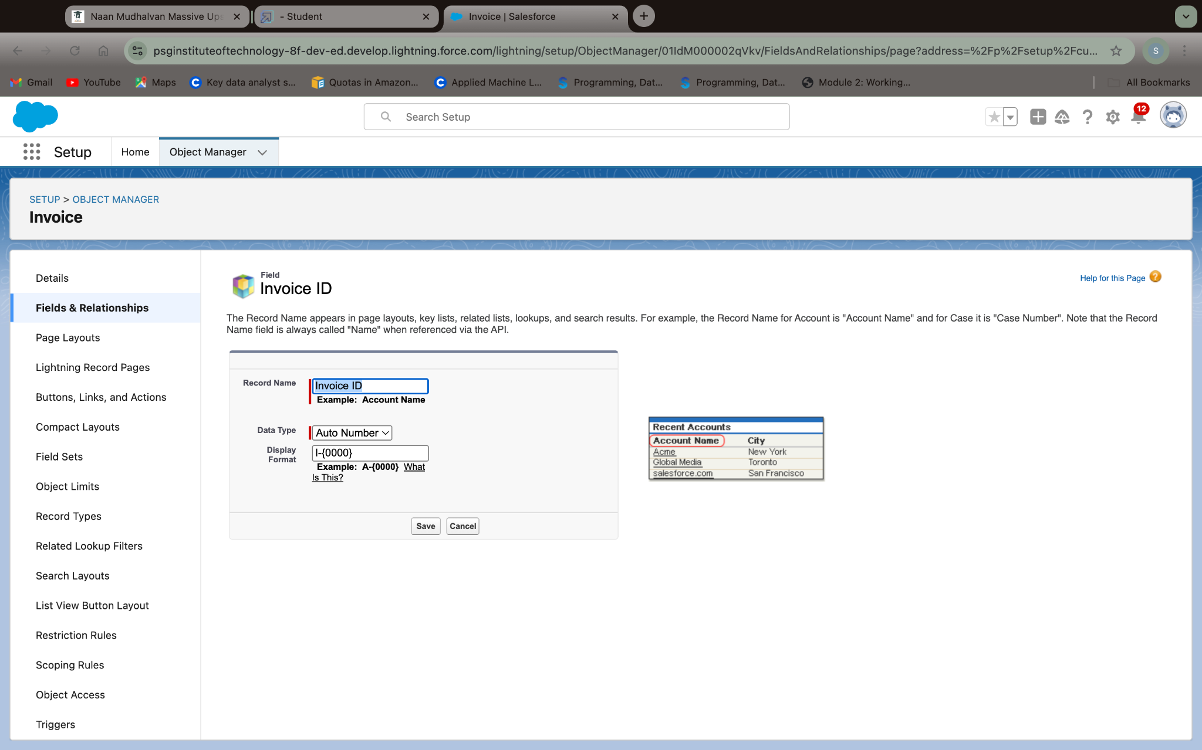

1. Creating Remaining Fields in Objects

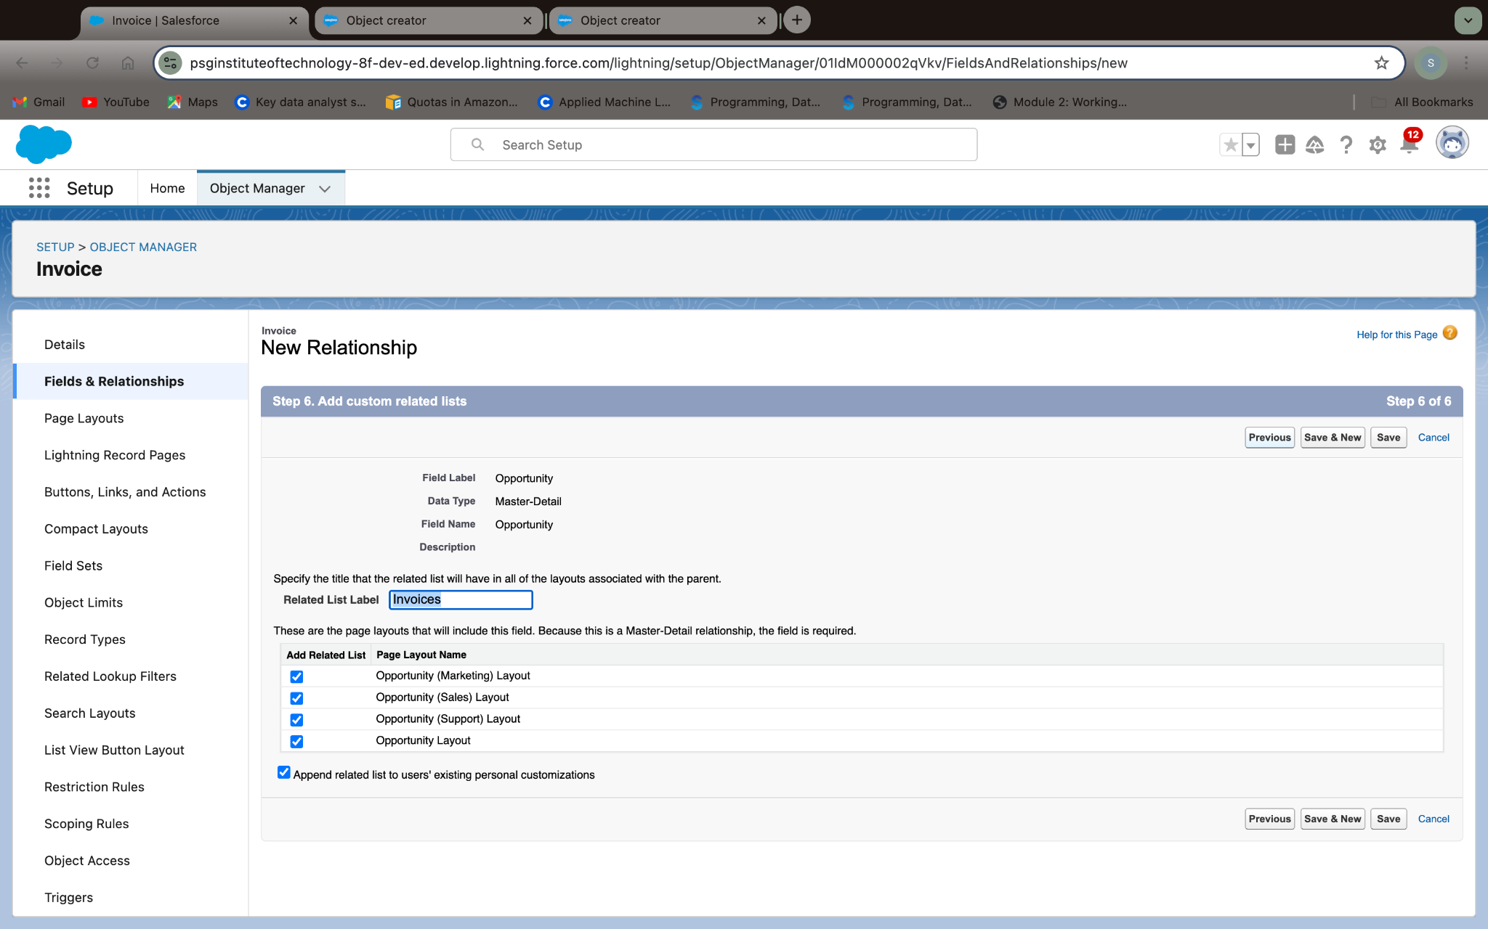

1. Layout for Opportunity Object:

* Access Opportunity Layout
  + Go to Setup → Object Manager → In the Quick Find bar, type Opportunity.
  + Under Opportunity, click on Page Layouts on the left panel.
* Edit Opportunity Layout
  + Click on Opportunity Layout.
  + Make any necessary adjustments to the fields, sections, and layout for a better user experience.
  + Once you're done, click Save.

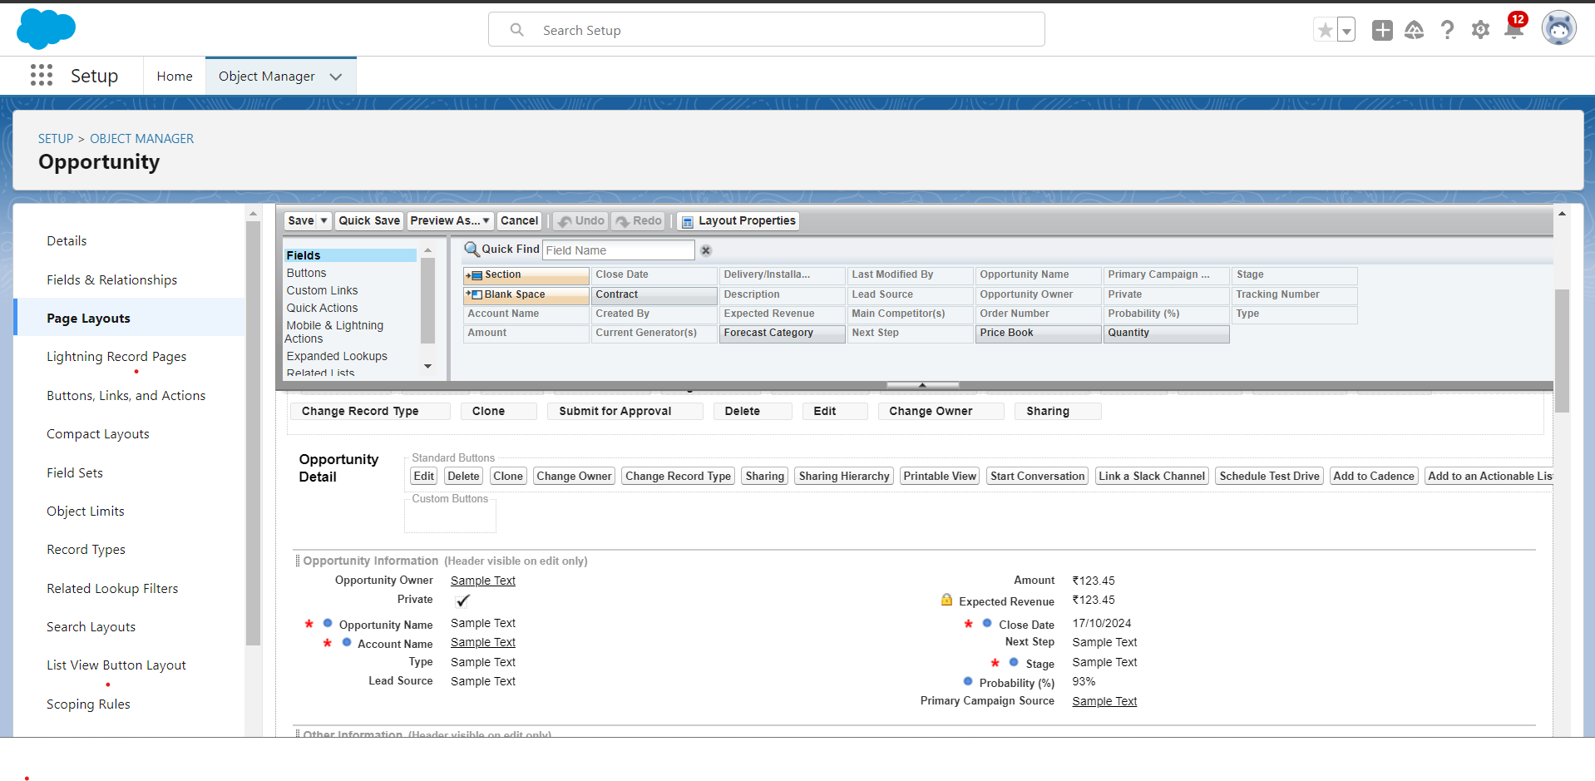

1. Layout for Automobile Information

* Access Automobile Information Layout
  + Go to Setup → Object Manager → In the Quick Find bar, type Automobile Information.
  + Under Automobile Information, click on Page Layouts on the left panel.
* Edit Automobile Information Layout
  + Click on Automobile Information Layout.
  + For each field in the Automobile Information Object, click the Gear Icon and mark the field as Required (similar to what you did for the Account Object). Once marked as required, the field will display in red.
* Adjust Fields for Better View
  + Organize and arrange the fields as needed to ensure a clean and structured layout.
  + Click Save once you've adjusted the fields for a good view.

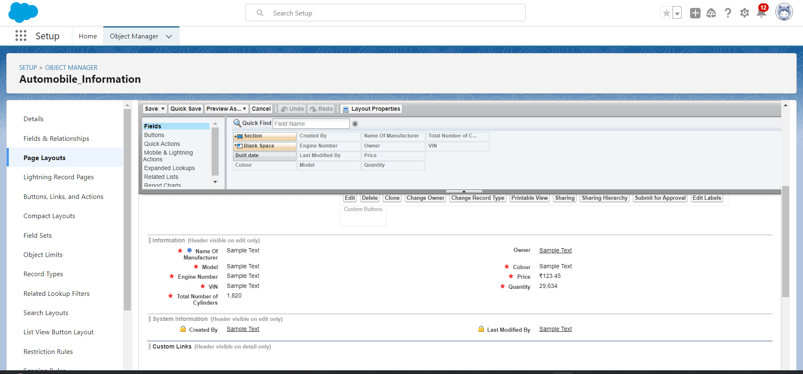

1. Adjusting the Account Field in Opportunity Layout

* Access Opportunity Detail Section
  + In the Opportunity Detail section, locate the Account field.
  + Click on the Properties Icon next to the Account Name field.
* Mark Account Field as Required
  + In the pop-up, check the Required box for the Account Name field.
  + Click OK.
* Save Changes
  + After making the necessary changes, click Save to apply them.

1. Opportunity Handler

* **Login to Salesforce:**
  + Go to your Trailhead account.
  + Click on the gear icon in the top right corner and select **Developer Console**.
* **Create a New Apex Class:**
  + In the Developer Console, click **File** > **New** > **Apex Class**.
  + Name the class as **OpportunityHandlerClass**.
* **Write code for OpportunityHandlerClass:**

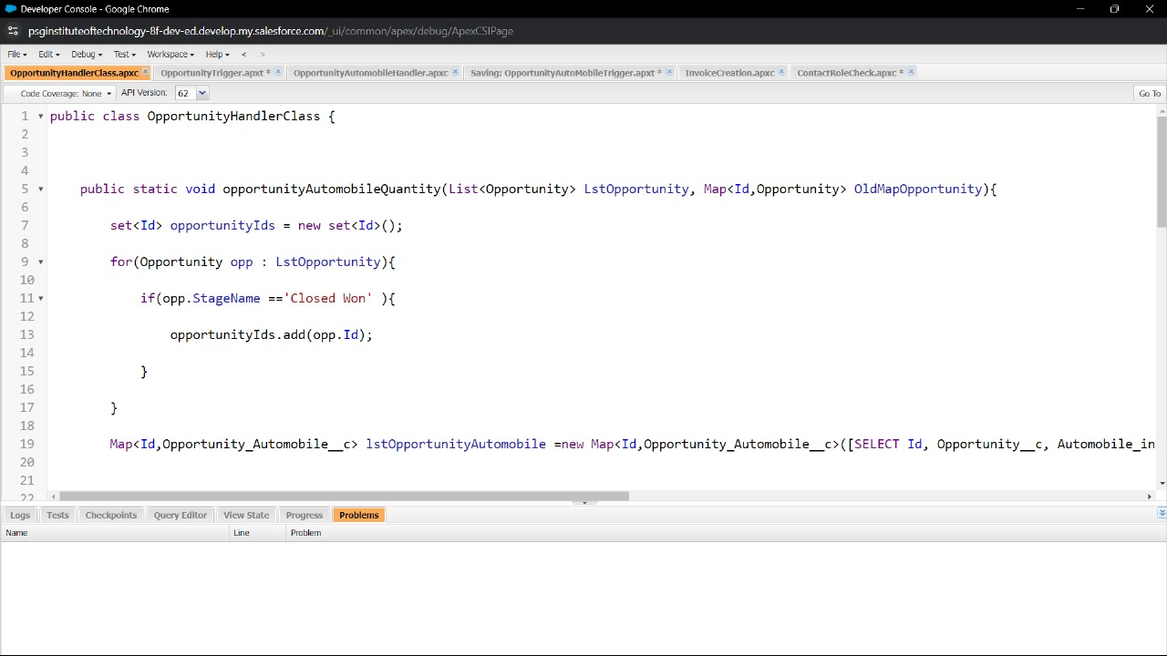

1. Opportunity Trigger
   * Click on **File** > **New** > **Trigger**.
   * Name the trigger as **OpportunityTrigger**.
   * Set **sObject** to **Opportunity**.

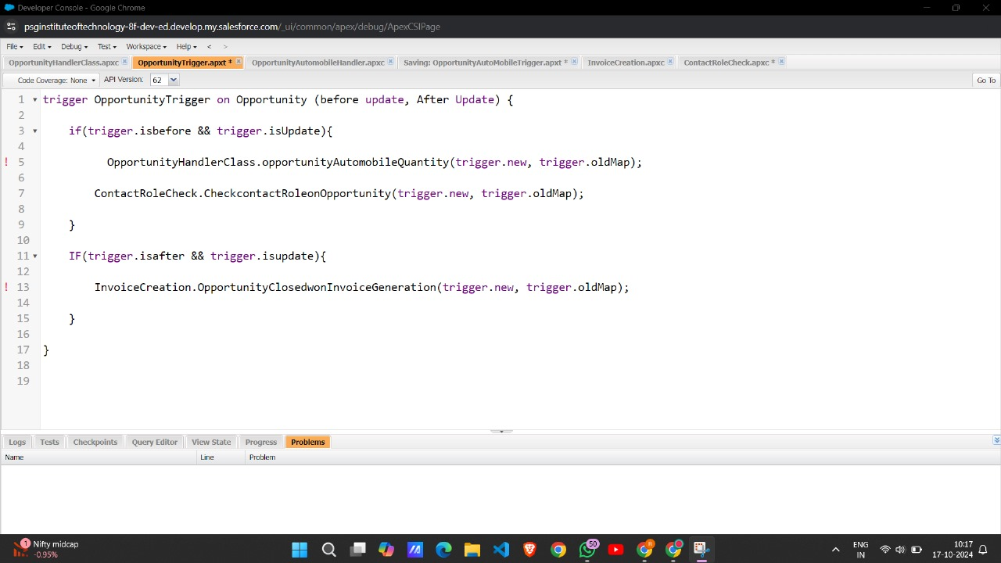

1. Opportunity AutoMobile Trigger

* **Create a New Apex Class:**
  + In the Developer Console, click **File** > **New** > **Apex Class**.
  + Name the class as **OpportunityAutomobileHandler**.
* **Write code for OpportunityAutomobileHandler:**

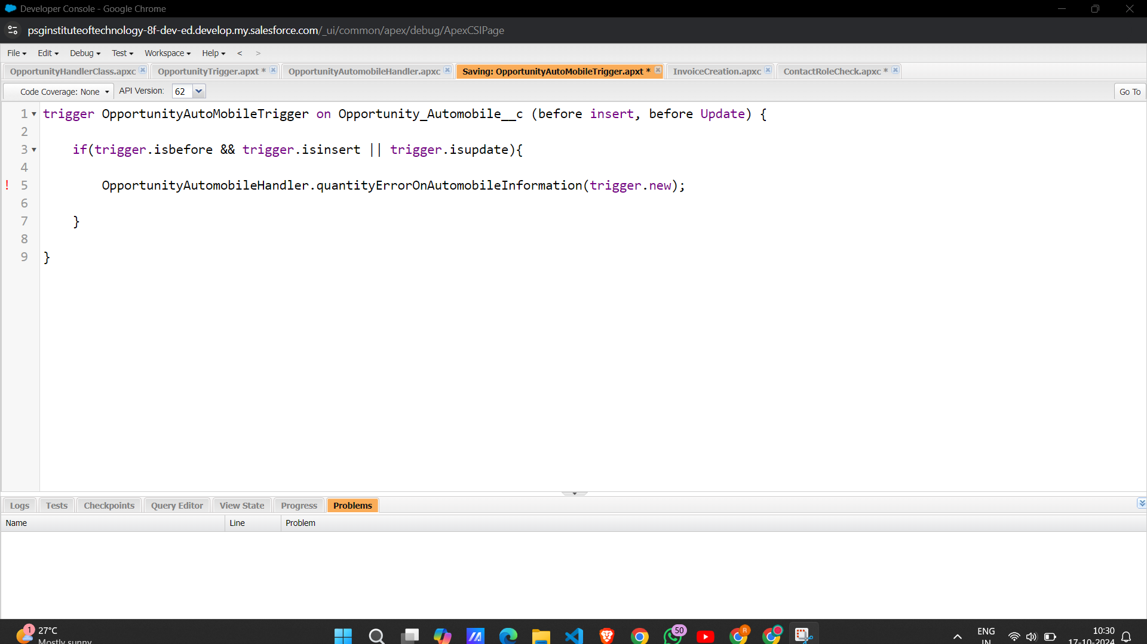

1. Invoice Creation

* **Create a New Apex Class:**
  + In the Developer Console, click **File** > **New** > **Apex Class**.
  + Name the class as **InvoiceCreation**.
* **Write code for InvoiceCreation**

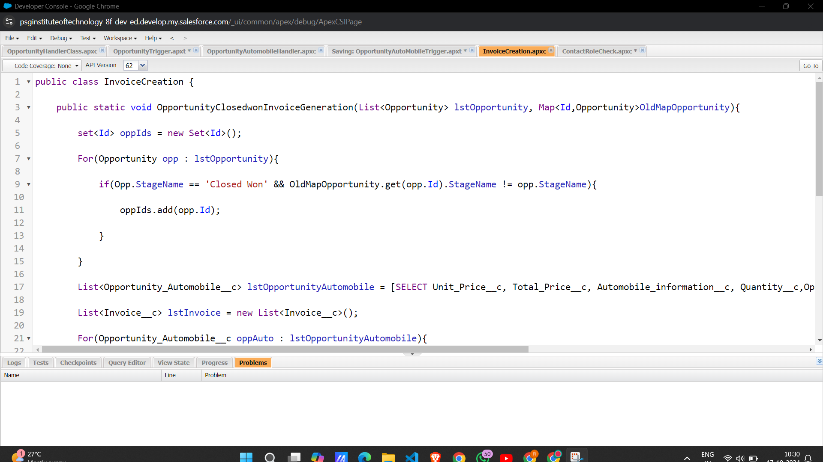

1. Contact Role Check

* **Create a New Apex Class:**
  + In the Developer Console, click **File** > **New** > **Apex Class**.
  + Name the class as **ContactRoleCheck**.
* **Write code for ContactRoleCheck:**

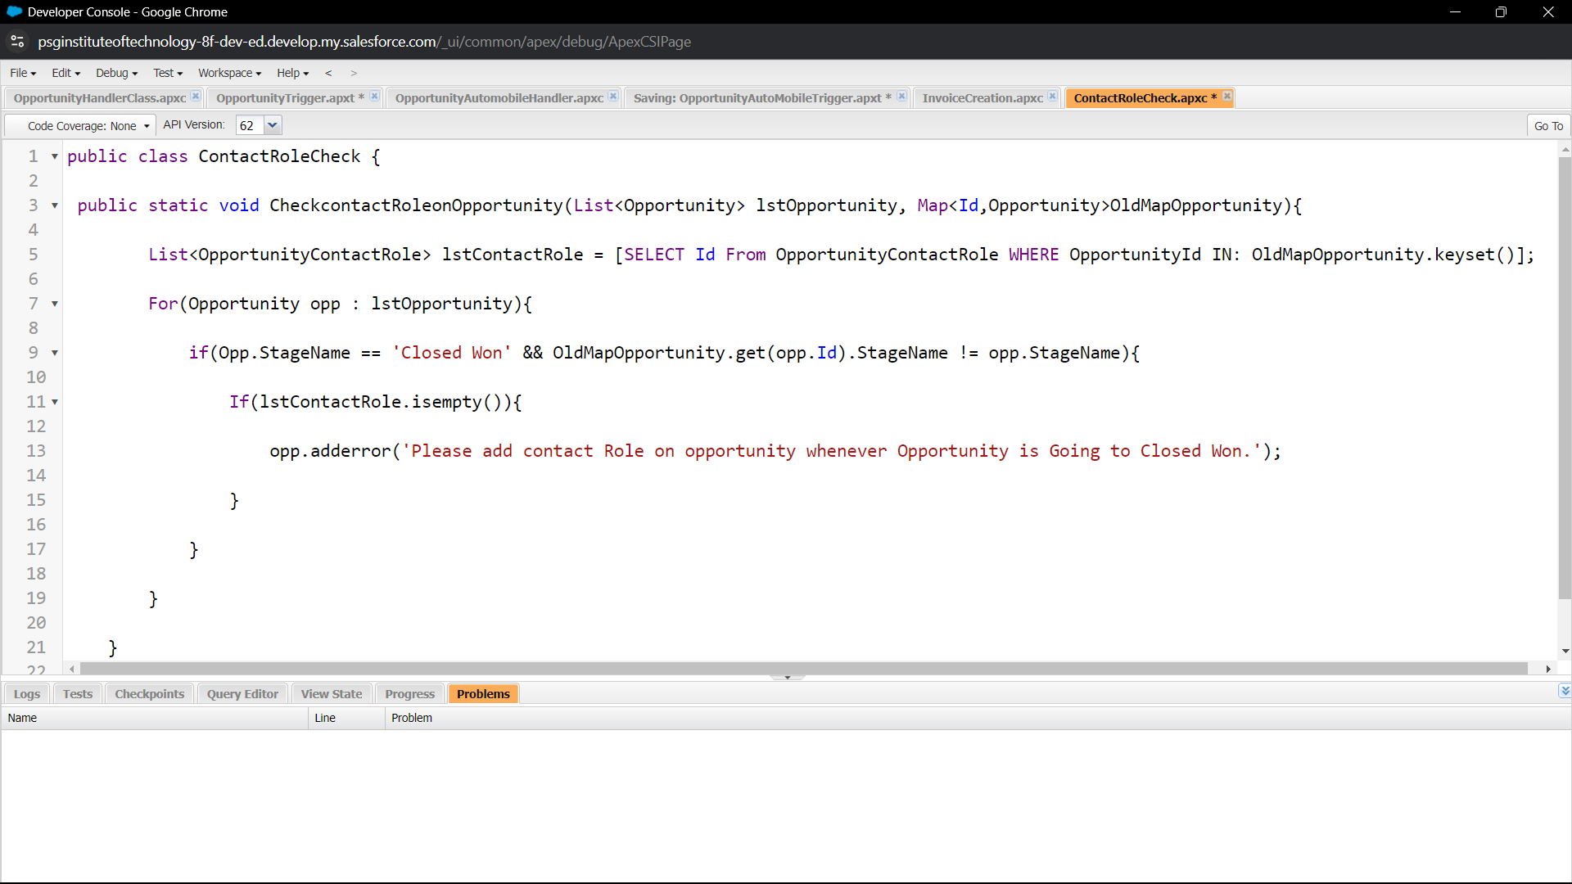

1. Create Apex Class to Get Invoices

* Open the **Developer Console** in Salesforce:
  + Click the gear icon in the top-right corner and select **Developer Console**.
* In the **Developer Console**, go to **File > New > Apex Class** and name it OpportunityInvoiceswithLWC and write the code

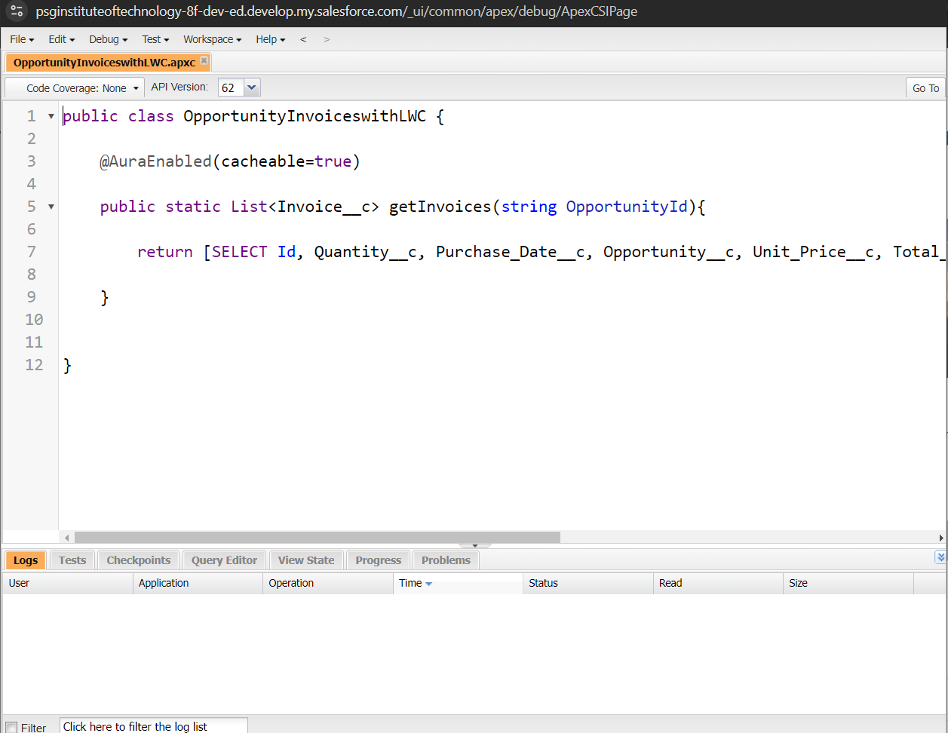

1. Install Salesforce CLI

To install Salesforce CLI and work with your Salesforce org locally:

* Download and install Salesforce CLI from the [official page](https://developer.salesforce.com/tools/sfdxcli).

To confirm the installation, open a command prompt and type:  
sfdx --version

* This should return the installed version of Salesforce CLI.

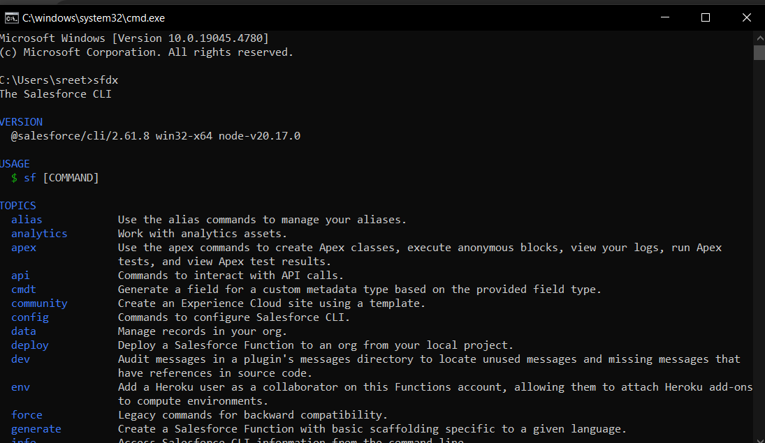

1. Install Microsoft VS Code

* Download and install [Visual Studio Code (VS Code)](https://code.visualstudio.com/).

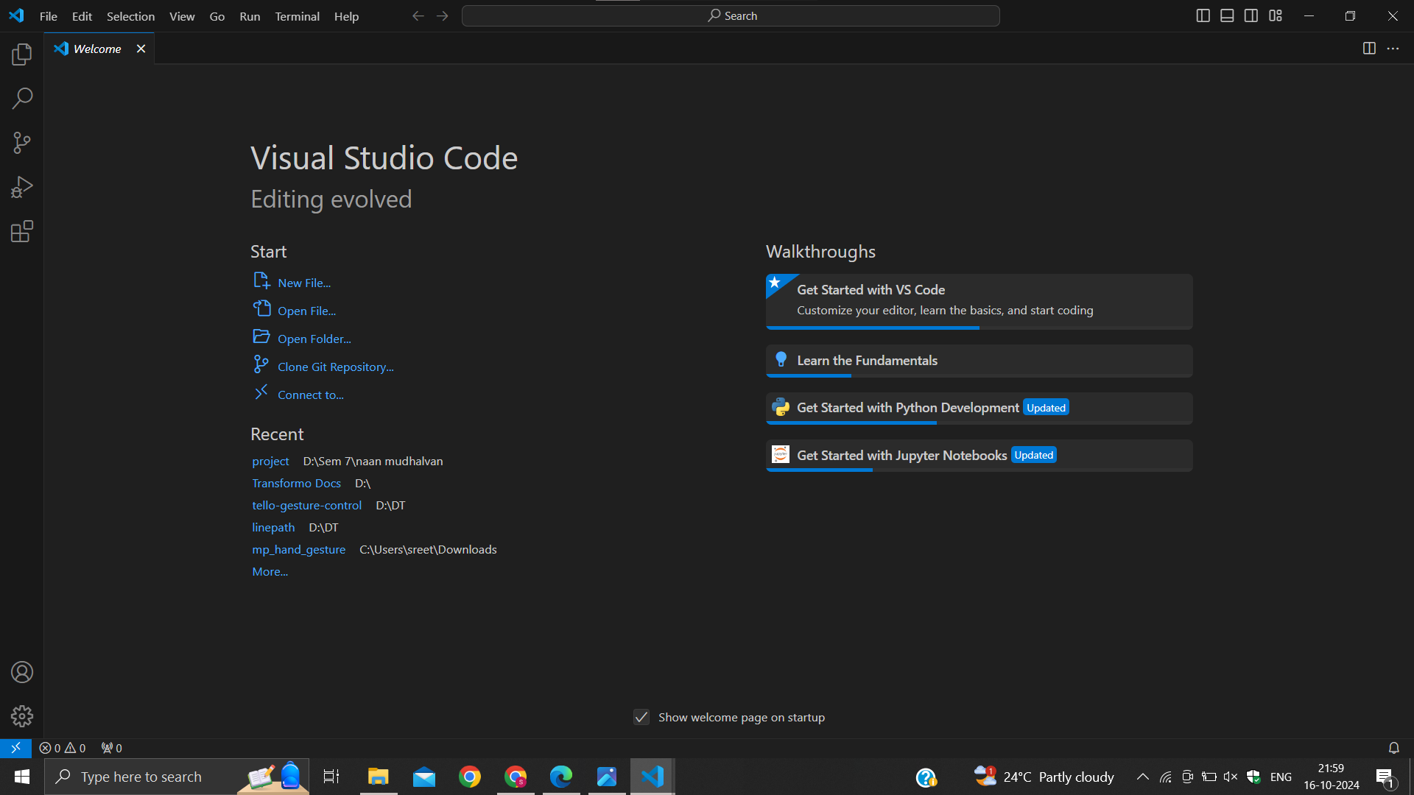

1. Install the Salesforce Extension Pack

* Open VS Code and go to the **Extensions** panel.
* Search for **Salesforce Extension Pack**.
* Install the extension pack to get the necessary tools for Salesforce development.

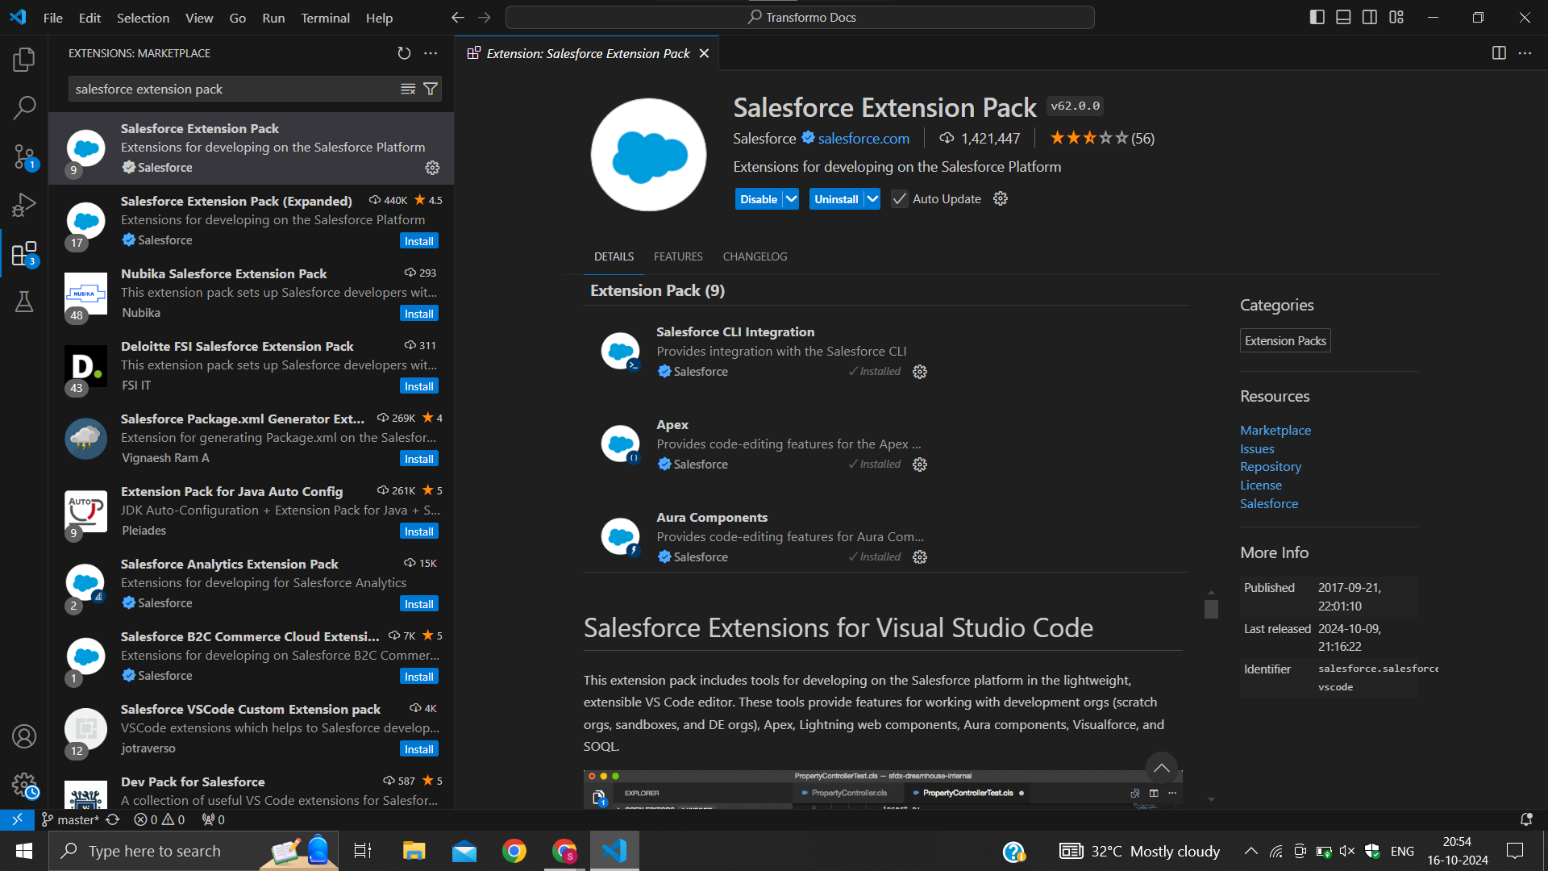

1. Create a project in VS Code

* Press Ctrl + Shift + P and type SFDX: Create Project with Manifest.
* Select a project template (e.g., **Standard Project Template**).
* Name your project and create a directory for it.

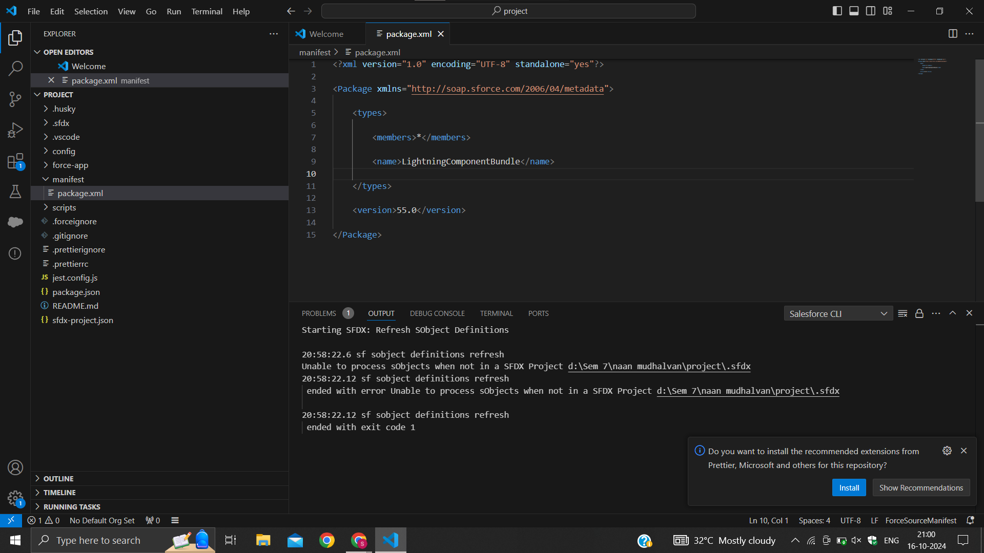

1. Authorize an org

* Press Ctrl + Shift + P and type SFDX: Authorize an Org.
* Select the org type (e.g., **Production** or **Developer Edition**).
* Log in to your Salesforce account when prompted.

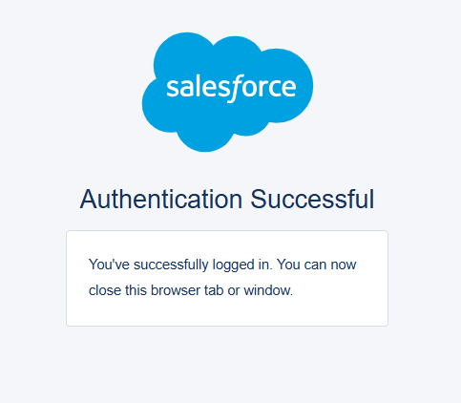

1. Create Lightning Web Component

* Press Ctrl + Shift + P and type SFDX: Create Lightning Web Component.
* Name the component InvoiceOpportunity and choose the desired directory.

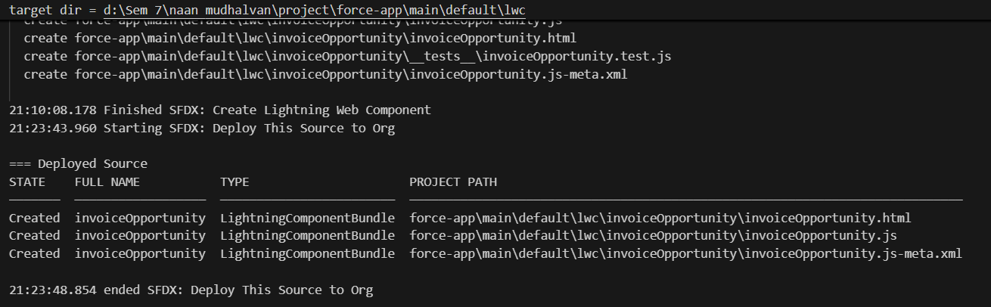

1. Create Button to Add on Opportunity

* Go to **Salesforce Setup**.
* Search for **Opportunity** in **Object Manager** and select it.
* Go to **Buttons, Links, and Actions** and create a new action:
  + Action Type: **Lightning Web Component**
  + Select the InvoiceOpportunity component.
  + Label: "Invoices"
  + Name: "Invoices"
* Save the action.

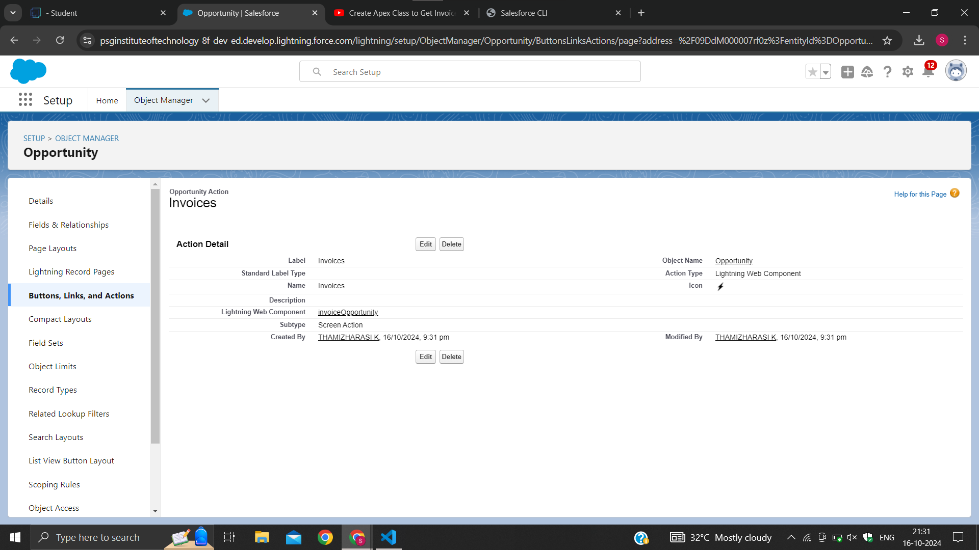

1. Add InvoiceOpportunity into Opportunity Record Page

* Go to **Opportunity Page Layout**.
* Drag and drop the **Invoices** action into the **Salesforce Mobile and Lightning Experience Actions** section.
* Save the page layout.

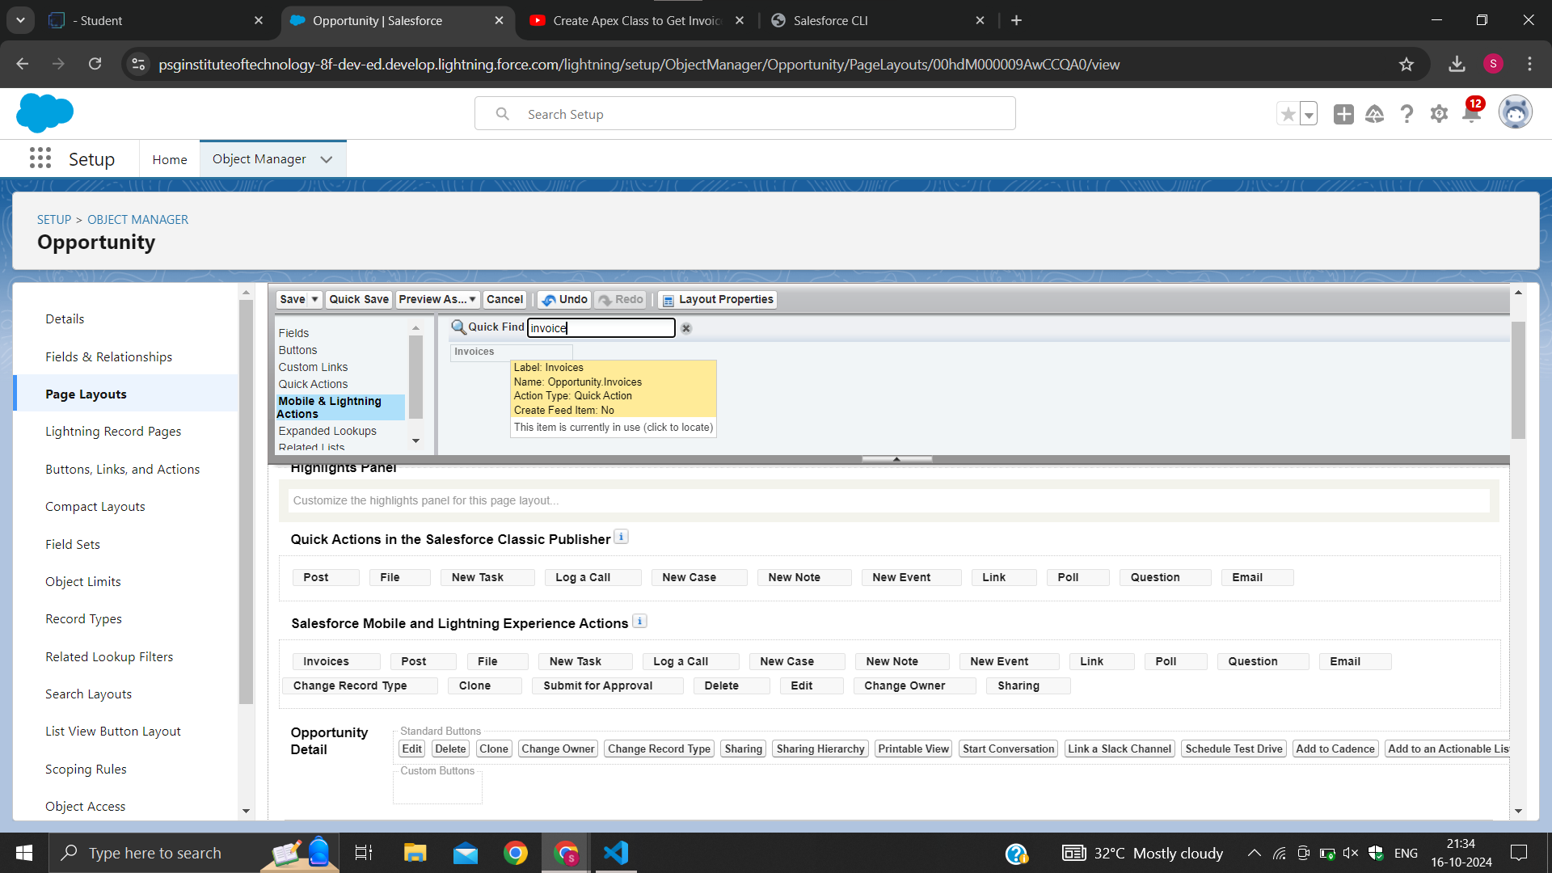

1. Delete opportunity Schedule Class

* **Login** to Salesforce and navigate to the **Developer Console** by clicking the gear icon in the top right corner.
* In the **Developer Console**, go to the **File** menu and select **New** > **Apex Class**.
* Name the class DeleteClosedLostOpportunities and click **OK**.
* In the Apex editor, write code to implement the Schedulable interface

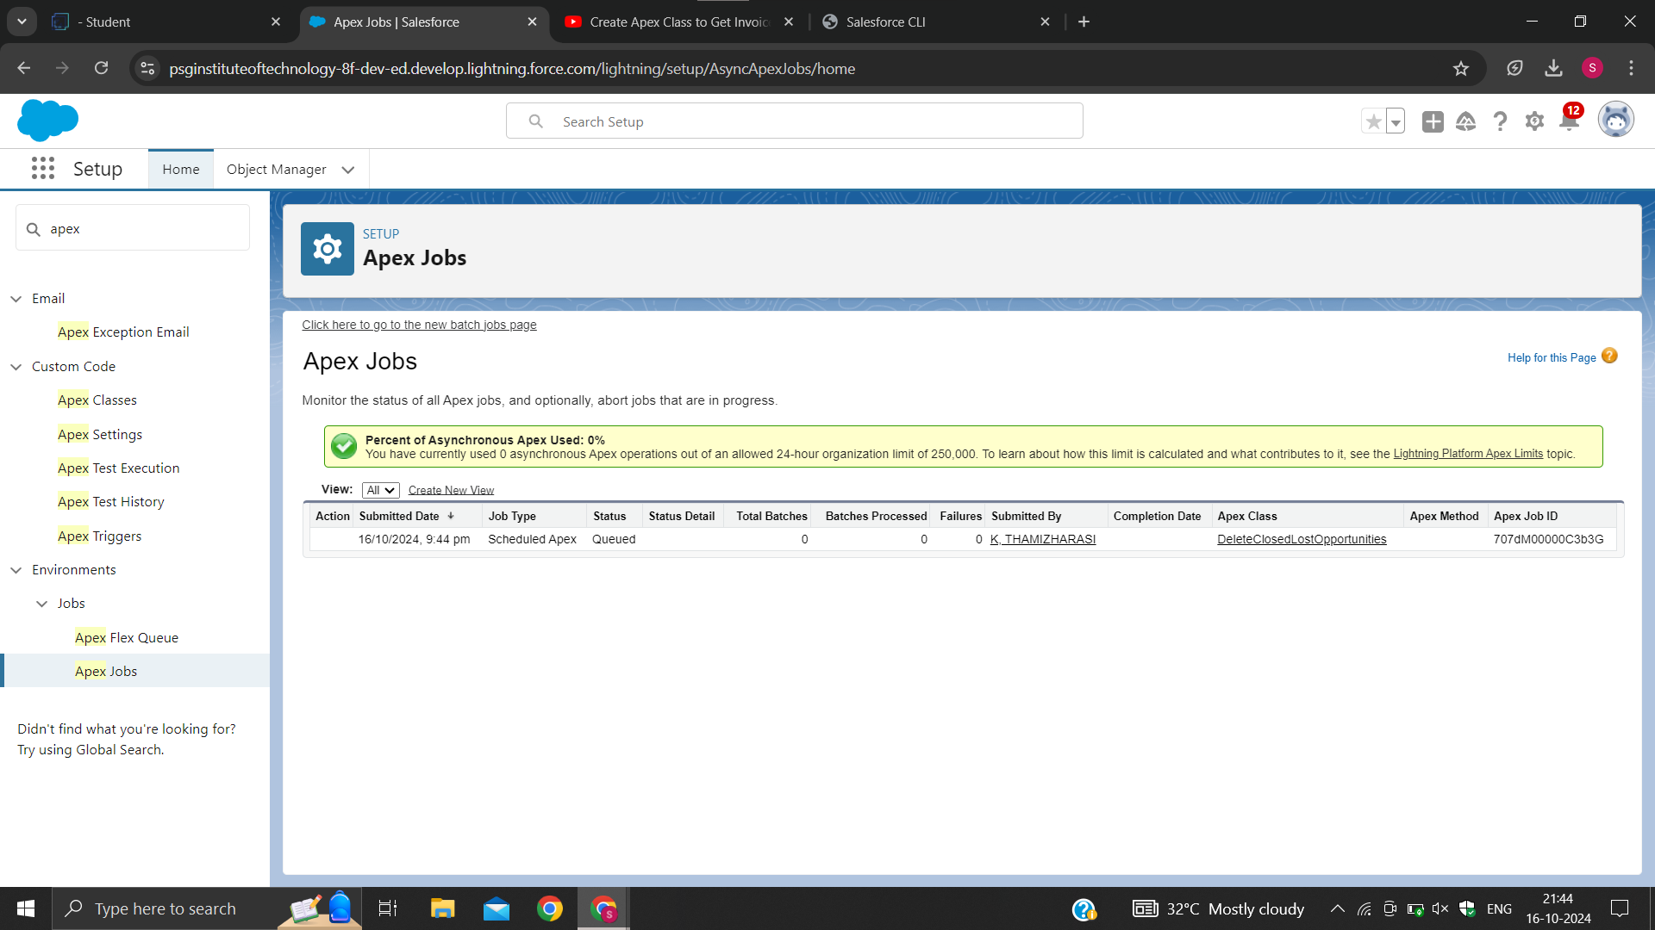

* Go to the **Home page** in your Salesforce account.
* In the search bar, type **Apex Classes** and click on it.
* In the **Apex Classes** page, click the **Schedule Apex** button.
* Enter a **Job Name** for your scheduled job, e.g., DeleteOpportunitySchedule.
* In the **Apex Class** field, click on the **Lookup icon** (magnifying glass).
* In the pop-up, search for and select the DeleteClosedLostOpportunities class you just created.
* Set the **Frequency** to **Weekly** and choose **Monday** as the preferred day to run the job.
* Set the **Preferred Time** to 10:00 AM (or any desired time).
* Click **Save** to schedule the job.

1. Create Report on Opportunity

**Steps to Create Opportunity Report:**

* **Navigate to the App:**
  + Open your Salesforce instance.
  + Go to the **App** that you use for reports (e.g., Sales or your custom app).
* **Go to Reports Tab:**
  + Click on the **Reports** tab in the navigation bar.
* **Create a New Report:**
  + Click on **New Report**.
* **Select Report Type:**
  + In the **Choose Report Type** window, search for **Opportunity** and select the appropriate report type. Typically, you would select **Opportunities** or **Opportunities with Products** depending on your needs.
  + Click **Continue**.
* **Customize the Report:**
  + In the **Report Builder**, you can now customize your report by adding relevant fields from the **Field Pane** on the left side.
  + You may want to include fields such as:
    - Opportunity Name
    - Opportunity Stage
    - Amount
    - Close Date
    - Account Name
    - Opportunity Owner
    - Probability
* **Add Filters:**
  + Add filters to refine your report:
    - **Stage**: Closed/Won or Open Opportunities
    - **Close Date**: You can filter by specific time frames (e.g., Last 30 Days, Current Fiscal Year).
    - **Opportunity Owner**: Filter by owner, if needed.
    - You can customize filters based on the data you want to focus on.
* **Run or Save the Report:**
  + Once you've added all the fields and filters, you can either **Run** the report to view the data or **Save** it for later use.
  + Name the report and choose the folder to save it in.

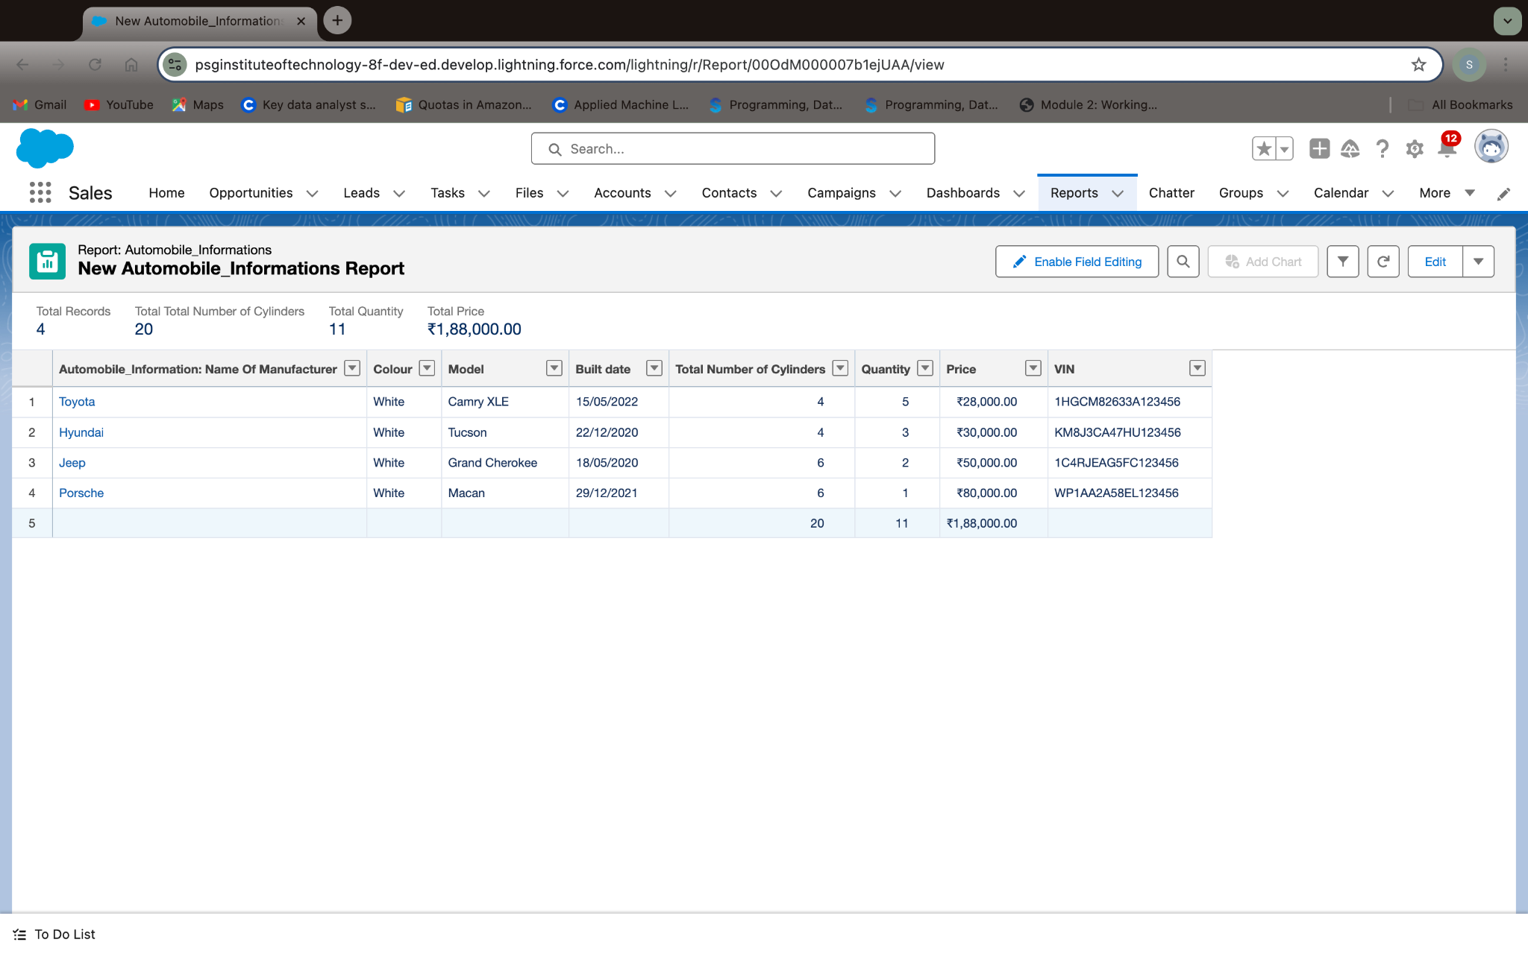

1. Create the Automobile Sales Dashboard

* **Navigate to the App:**
  + Open your Salesforce instance and go to the **App** you use for reports and dashboards (e.g., Sales or a custom app).
* **Go to the Dashboards Tab:**
  + Click on the **Dashboards** tab in the navigation bar.
* **Create a New Dashboard:**
  + Click on the **Create New Dashboard** button (or **New Dashboard** if you see that option).
* **Name Your Dashboard:**
  + In the pop-up window that appears, provide a name for the dashboard.
  + For example: **Automobile Sales Dashboard**.
  + Optionally, add a description or select a folder where you want to save the dashboard.
  + Click on **Create**.
* **Add a Component to the Dashboard:**
  + After creating the dashboard, you’ll be taken to the dashboard builder.
  + Click on the **Add Component** button.
* **Select a Report:**
  + You will be prompted to select a report to display in your dashboard component.
  + Choose the appropriate **Automobile Sales Report** that you created earlier or a relevant report such as **Opportunities with Automobiles** or **Automobile Sales Summary**.
  + After selecting the report, click on **Select**.
* **Customize the Component:**
  + You can customize the component’s display settings (e.g., chart type, filters, etc.).
  + Adjust how the data is visualized (e.g., bar chart, pie chart, table).
  + Choose the visualization that best represents the **Automobile Sales** data (e.g., total sales by model, number of closed opportunities, etc.).
* **Save the Component:**
  + After customizing the component, click **Add** to add it to the dashboard.
  + You can add multiple components if needed (e.g., another chart or table for more insights).
* **Save the Dashboard:**
  + Once you've added all the components you want, click **Save** to save the dashboard.
* **Finalize the Dashboard:**
  + Click on **Done** to complete the dashboard creation process.

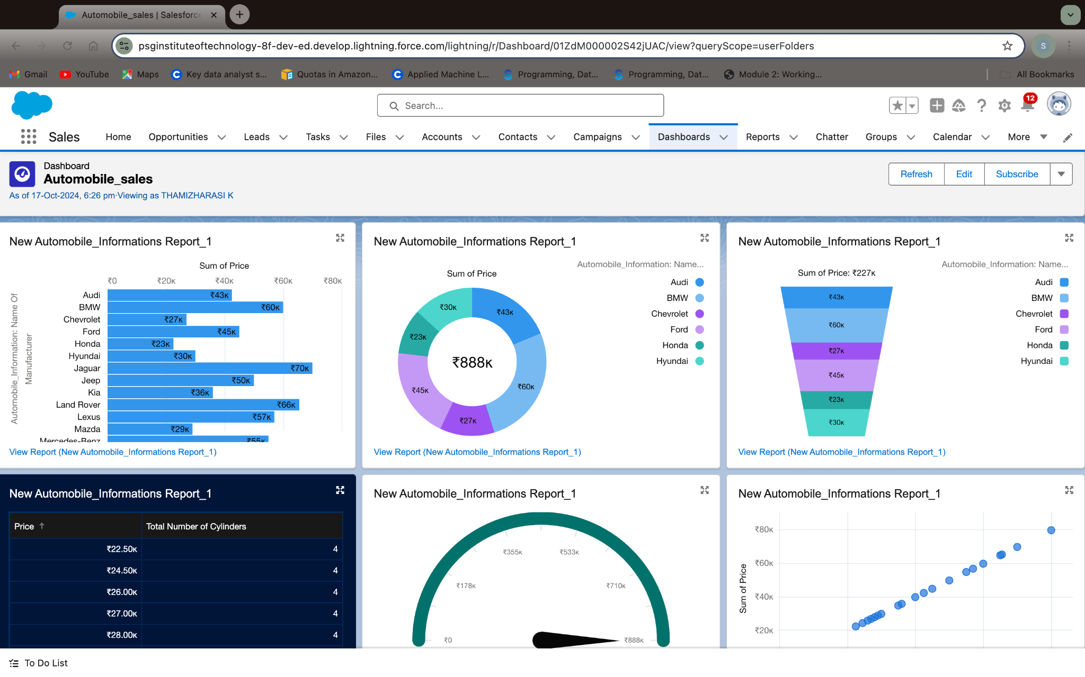

1. **Key Scenarios Addressed by Salesforce in the Implementation Project**

* Lead Management and Nurturing: Salesforce enables efficient lead tracking and nurturing, ensuring quick responses and maximizing conversion rates.
* Customer Data Centralization: All customer profiles, preferences, and interaction histories are organized in one place, supporting personalized engagement.
* Inventory Availability and Updates: Real-time vehicle availability, specifications, and pricing data are managed within Salesforce, helping sales teams provide accurate, up-to-date information.
* Automated Sales Workflows: Routine tasks such as follow-ups and reminders are automated, allowing the sales team to focus on high-value activities.
* Analytics and Reporting for Strategic Planning: Salesforce analytics tools deliver actionable insights, helping managers identify trends, forecast demand, and make data-driven decisions.

1. **Conclusion**

The Sales Automobile Using Salesforce CRM project has successfully enhanced lead management, centralized customer data, optimized inventory tracking, and streamlined sales workflows. Automation and advanced analytics have empowered sales teams to increase productivity, provide personalized service, and make informed strategic decisions. The CRM solution has positioned the sales team to achieve higher conversion rates, greater customer satisfaction, and improved operational efficiency.